Polynomial Graph 1
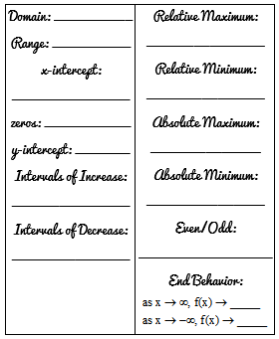
Polynomial Graph 2
Polynomial Graph 3
Polynomial Graph 4
Polynomial Graph 5
Polynomial Graph 6
Polynomial Graph 7
Polynomial Graph 8

