Algebra 2 Name: \_\_\_\_\_\_\_\_\_\_\_\_\_\_\_\_\_\_\_\_\_\_\_\_\_\_

Final Exam – Study Guide Date: \_\_\_\_\_\_\_\_\_\_\_\_\_\_ Block: \_\_\_\_\_

**Unit 4 Review: Radicals & Rational Exponents**

Perform the indicated operation. Write your answer in simplest form.

|  |  |
| --- | --- |
| 1.) | 2.) |
| 3.) | 4.) |
| Rewrite the expression in radical form.  5.)  6.) | Rewrite the expression with rational exponents.  7.)  8) |

|  |  |
| --- | --- |
| 9) Simplify the expression . |  |

10. Perform the indicated operation

11. State the radical conjugate for the expression  and then simplify completely.

Simplify each expression completely. Write your answer in simplest radical form.

|  |  |  |  |
| --- | --- | --- | --- |
| 12) | 13) | | 14) |
| 15) | 16) | | 17) |
| 18.) | | 19.) | |

Describe the characteristics for each function.

20. 

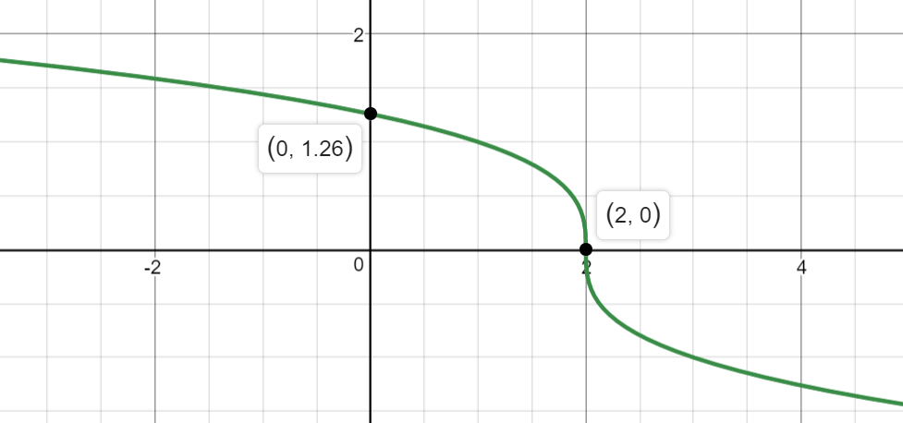

|  |  |  |
| --- | --- | --- |
| Domain: \_\_\_\_\_ Range: \_\_\_\_\_\_ | x-intercept: \_\_\_\_\_\_\_ | y-intercept: \_\_\_\_\_\_\_ |
| Interval of Increase:  Interval of Decrease: | Absolute Maximum:  Absolute Minimum: | End Behavior: |

21. 

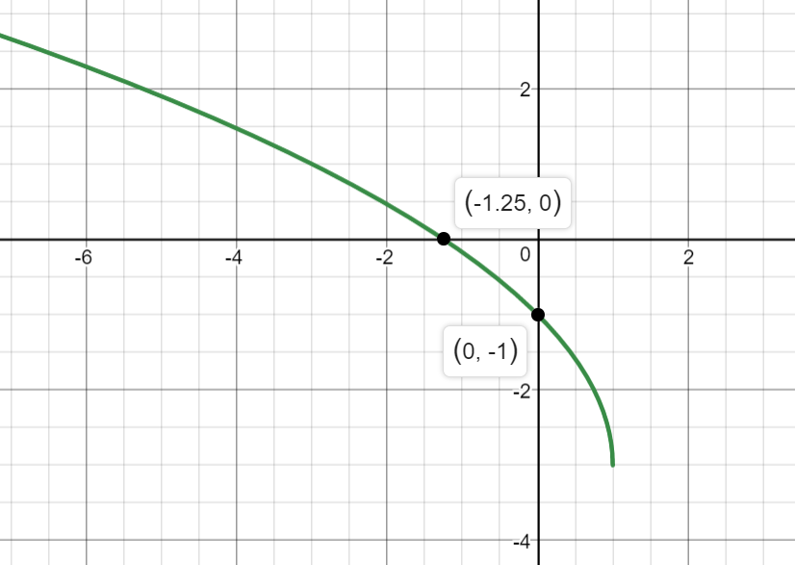

|  |  |  |
| --- | --- | --- |
| Domain: \_\_\_\_\_ Range: \_\_\_\_\_\_ | x-intercept: \_\_\_\_\_\_\_ | y-intercept: \_\_\_\_\_\_\_ |
| Interval of Increase:  Interval of Decrease: | Absolute Maximum:  Absolute Minimum: | End Behavior: |

Graph using transformations. Make sure to include the parent function on your graph.

22. 

|  |  |  |  |  |
| --- | --- | --- | --- | --- |
| Parent Function: | Vertical Reflection: | Horizontal Reflection: | Horizontal Shift: Direction? How many? | Vertical Shift: Direction? How many? |
|  |  |  |  |  |

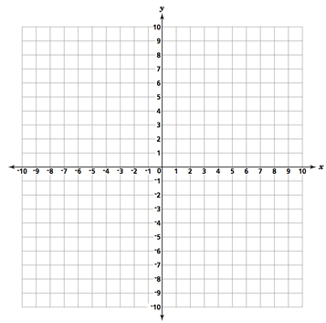

23. 

|  |  |  |  |  |
| --- | --- | --- | --- | --- |
| Parent Function: | Vertical Reflection: | Horizontal Reflection: | Horizontal Shift: Direction? How many? | Vertical Shift: Direction? How many? |
|  |  |  |  |  |



Solve each equation; round any decimal to the TENTHS place. Remember to check for extraneous solutions

|  |  |
| --- | --- |
| 24. | 25. |
| 26. | 27. |

**Unit 5 Review: Exponential Functions**

Sketch the general shape of an exponential function given the following…

|  |  |
| --- | --- |
| 28. | 29. |
| 30. What must be true about a and b of the function  that corresponds to the given graph? | |

State whether each of the given functions represents exponential growth or decay. Then identify the “a” and “b” values.

|  |  |
| --- | --- |
| 31.  a = \_\_\_\_\_\_\_\_ b = \_\_\_\_\_\_\_ | 32.  a = \_\_\_\_\_\_\_\_ b = \_\_\_\_\_\_\_ |
| 33.  a = \_\_\_\_\_\_\_\_ b = \_\_\_\_\_\_\_ | 34.  a = \_\_\_\_\_\_\_\_ b = \_\_\_\_\_\_\_ |

35. Match the graph with the correct function below.

 A. 

B. 

C. 

D. 

Identify the characteristics for the functions given below.

|  |  |
| --- | --- |
| 36. | Domain: \_\_\_\_\_\_\_\_\_\_\_\_\_\_\_\_\_ Range: \_\_\_\_\_\_\_\_\_\_\_\_\_\_\_\_\_  Horizontal Asymptote: \_\_\_\_\_\_\_\_\_\_ X-Intercept: \_\_\_\_\_\_\_\_\_\_\_\_\_\_\_\_  Y-Intercept: \_\_\_\_\_\_\_\_\_\_\_\_\_\_\_\_ Interval of Increase or Decrease: \_\_\_\_\_\_\_\_\_\_\_  End Behavior: |
| 37. | Domain: \_\_\_\_\_\_\_\_\_\_\_\_\_\_\_\_\_ Range: \_\_\_\_\_\_\_\_\_\_\_\_\_\_\_\_\_  Horizontal Asymptote: \_\_\_\_\_\_\_\_\_\_ X-Intercept: \_\_\_\_\_\_\_\_\_\_\_\_\_\_\_\_  Y-Intercept: \_\_\_\_\_\_\_\_\_\_\_\_\_\_\_\_ Interval of Increase or Decrease: \_\_\_\_\_\_\_\_\_\_\_  End Behavior: |

Identify the transformations for the functions given below. Then graph the function using transformations.

|  |  |  |  |  |  |  |  |  |  |  |  |  |  |
| --- | --- | --- | --- | --- | --- | --- | --- | --- | --- | --- | --- | --- | --- |
| 38. | | | | | | | | | | | | | |
| Parent Function: | | Vertical Reflection? | | Horizontal Reflection? | | | | | Horizontal Shift: Direction? How many? | | Vertical Shift: Direction? How many? | | |
|  | |  | |  | | | | |  | |  | | |
| Starting Points: | | | | | | | Horizontal Asymptote: | | | | | | |
|  | | | | | | |  | | | | | | |
| 39. | | | | | | | | | | | | |
| Parent Function: | Vertical Reflection? | | Horizontal Reflection? | | | | | Horizontal Shift: Direction? How many? | | Vertical Shift: Direction? How many? | | |
|  |  | |  | | | | |  | |  | | |
| Starting Points: | | | | | | Horizontal Asymptote: | | | | | | |
|  | | | | | |  | | | | | | |
| Graph # 38 Here:  2690_4[2] | | | | | Graph # 39 Here:  2690_4[2] | | | | | | |

Solve each equation.

|  |  |  |
| --- | --- | --- |
| 40. | 41. | 42. |

Match the application formula with the correct name.

|  |  |
| --- | --- |
| 43. Exponential Growth | A. |
| 44. Exponential Decay | B. |
| 45. Compound Interest | C. |
| 46. Compound Continuously | D. |

47. Suppose that $ 12000 is invested at 6% compounded quarterly.

a. What will the investment be worth after 5 years?

b. How much interest has been earned in the first 5 years?

48. You bought a guitar 6 years ago for $400, and its value is decreasing by about 13% per

year. How much is your guitar worth now?

49. Your grandparents opened a college savings account for you on the day you were born. They found an investment that pays 8% annual interest, compounded monthly. How much money did they need to invest in order to have $40,000 in the account on your 18th birthday?

50. Find the interest on $2500 when invested at 4.8% annual interest compounded monthly for an eight year period.

51. A colony of algae increases in size by 15% each week. If 10 grams of algae are placed in a lake, find the weight of the algae that will be present in the lake after 12 weeks.

**Unit 6 Review: Logarithmic Functions**

|  |  |  |  |  |  |  |  |  |  |  |  |  |  |  |  |  |  |  |  |  |  |  |  |  |  |  |  |  |  |
| --- | --- | --- | --- | --- | --- | --- | --- | --- | --- | --- | --- | --- | --- | --- | --- | --- | --- | --- | --- | --- | --- | --- | --- | --- | --- | --- | --- | --- | --- |
| *Keeper # 35: Logarithmic Functions*  Rewrite each equation in exponential form.   |  |  | | --- | --- | | 52.) | 53.) |   Rewrite each equation in logarithmic form.   |  |  | | --- | --- | | 54.) | 55.) |   Evaluate. Round any decimal answers to the hundredths place.   |  |  |  | | --- | --- | --- | | 56.) | 57.) | 58.) |   *Keeper # 36: Properties of Logarithms*  Expand the logarithm.   |  |  | | --- | --- | | 59.) | 60.) |   Condense the logarithm.   |  |  | | --- | --- | | 61.) | 62.) |   Use the change of base formula to evaluate.   |  |  | | --- | --- | | 63.) | 64.) |   *Keeper # 37: Solving using Logs*  Solve. Round your answer to the hundredths place if necessary.   |  |  | | --- | --- | | 65.) | 66.) | | 67.) | 68.) | | 69.) | 70.) | | 71.) | 72.) |   *Keeper # 38:* Determine the inverse.   |  |  | | --- | --- | | 73.) | 74.) | | 75.) | 76.) |   *Keeper #39: Characteristics & Graphing Logarithmic Functions*  Graph the function. Then identify the characteristics.   |  |  | | --- | --- | | 77.) | 78.) | | Domain: \_\_\_\_\_\_\_\_ Range: \_\_\_\_\_\_\_\_  x-intercept: \_\_\_\_\_\_\_ y-intercept: \_\_\_\_\_\_\_\_\_  Asymptote: \_\_\_\_\_\_\_\_\_\_\_\_\_\_\_\_\_\_\_\_\_\_\_\_\_\_\_\_  End Behavior:    Interval of Increase or Decrease: \_\_\_\_\_\_\_\_\_ | Domain: \_\_\_\_\_\_\_\_ Range: \_\_\_\_\_\_\_\_  x-intercept: \_\_\_\_\_\_\_ y-intercept: \_\_\_\_\_\_\_\_\_  Asymptote: \_\_\_\_\_\_\_\_\_\_\_\_\_\_\_\_\_\_\_\_\_\_\_\_\_\_\_\_  End Behavior:    Interval of Increase or Decrease: \_\_\_\_\_\_\_\_\_ | |

*Keeper # 40:: Applications of Logarithmic Functions*

|  |
| --- |
| 79.) Maryville was founded in 1950. At that time, 500 people lived in the town. The population growth in Maryville follows the equation $y =500+{1.5}^{t}$, where t is the number of years since 1950.  A. Determine when the population had doubled since the founding.  B. In what year was the population predicted to reach 25,000 people? |
| 80.) Tanisha has $100 to invest at 8% per year in an account that is compounded continuously.  A. How long will it be before she has $150?  B. What rate would Tanisha need to invest her money in order to make $300 in 7 years? |