Algebra 2 Name: ________________________________________
Synthetic Division Date: _______________________ Block: _______

Use synthetic division to divide each polynomial.
1.) 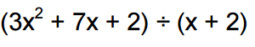
2.) 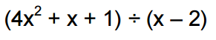
3.) 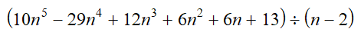
4.)
5.) 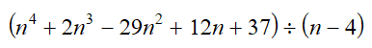
6.) 