Steps:
1.) Equation must = _____________ & written in ______________________________ form.

2.) Factor using the _____________________ method.

*Remember to start by taking out a ______________ if possible!
(All methods of factoring are fair game)

3.) Set each factor = 0 and solve.
*__________________________________________________________
*__________________________________________________________
*__________________________________________________________
*__________________________________________________________

The ______________ = the number of solutions!
Example: Solve by factoring.
1.) 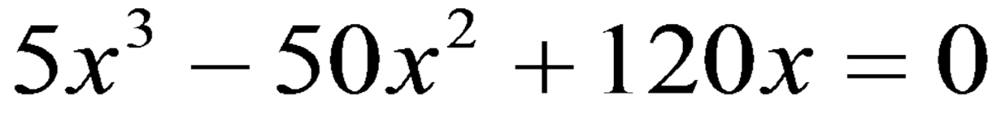

2.) 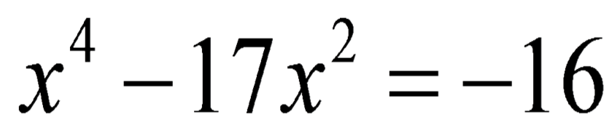

3.) 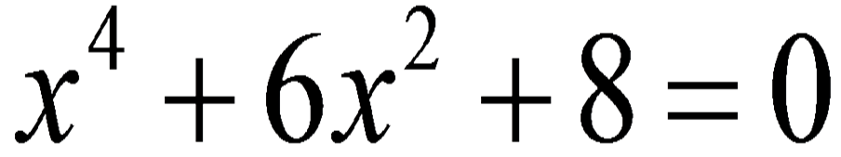

4.) 