**What does it mean to "factor?"**

Take an addition or subtraction problem and write it as an **____________________________** multiplication problem.

**How have I already seen “factoring?”**

When ___________________________ polynomials! Factoring is just the ______________________ direction.

**Example:** Multiply

2(x – 3)

**Factoring using GCF:**

**_____________________** start by taking check for a GCF __________________!

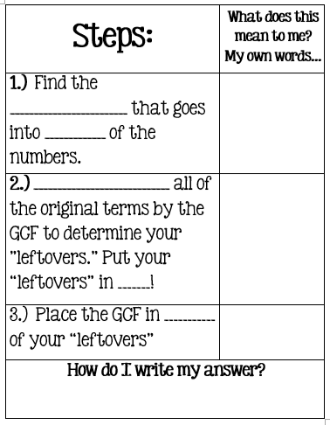

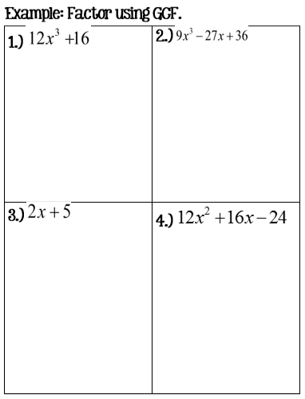

Factoring Quadratic Trinomials where A = 1

To factor, ask yourself...

___________________________________________________

____________________________________________________________

**Don't forget to ALWAYS start by looking for a GCF!**

Write your factors as:

(________)(_______)

|  |  |
| --- | --- |
| Split the quadratic in _______ and place at the __________ of each ( ). | Place your two numbers (with signs) in the ____________ of  each ( ). |

There are _________ possible sign combinations for these type of trinomials.

|  |  |  |  |
| --- | --- | --- | --- |
|  |  |  |  |
| Multiply to a (_) and Add to a (_) | Multiply to a (_) and Add to a (_) | Multiply to a (_) and Add to a (_) | Multiply to a (_) and Add to a (_) |
| Signs? | Signs? | Signs? | Signs? |

|  |  |
| --- | --- |
| **Examples: Factor** | |
|  |  |
|  |  |

Putting it all together!

**Example: Factor**

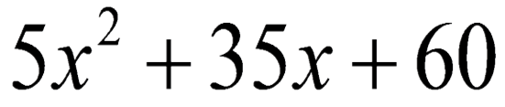

**Step # 1: _____________________________________________________**

**Step # 2: ______________________________________________________**