**In order to sketch the graph of a polynomial function, we need _______ characteristics:**

|  |
| --- |
| **Number of Turns** |
| *How many turns the graph has.  ________________ - __________ |
| **End Behavior** |
| *What f(x) does as we choose larger positive (right side) and larger negative (left side) x-values.   |  |  |  | | --- | --- | --- | |  | **Even Degree** | **Odd Degree** | | **+ LC** |  |  | | **- LC** |  |  | |
| **Finding Zeros** |
| *The values of x where the graph crosses the x-axis.   |  |  | | --- | --- | | **TI 36 Pro**   1. Select “Table” 2. Select # 2 - “Edit Function” 3. Enter the polynomial function and press “Enter” 5 times until a table of values appears. | **Graphing Calculator**   1. Select y = 2. Enter the function 3. Select 2nd and Graph | | Then scroll through the table to determine the values of x when y = 0. | |   *Remember your degree **______** = the number of solutions! So if all of the zeros DO NOT appear within the table, use **________________________** to divide out the zeros you can find and solve by (factoring, quadratic formula, square root method, or inverses) to find the rest.  *If any of your “zeros” have ________________**___________**, the graph will “______________,” which creates a ___________________ at the _____________.  *If any of your “zeros” turn out to be _______________________, then a ______________ occurs on the graph but **_________________________________** cross the x-axis. |
| **Y-Intercept** |
| *The point where the graph crosses the y-axis. The y-int. is always written as the point (0, y).  To calculate the y-intercept, plug in ZERO for x and simplify. **HINT:** This should result in the **________________** value of the polynomial. |

**Steps to Sketching:**

1.) Identify the ______ required characteristics.

2.) Plot the ________ and ________________.

3.) _________ the __________ for the ___________________.

4.) Use the ________________ to ________________ the arrow on the ___________ to the arrow on the _________.

**Example: Sketch a graph of the function**

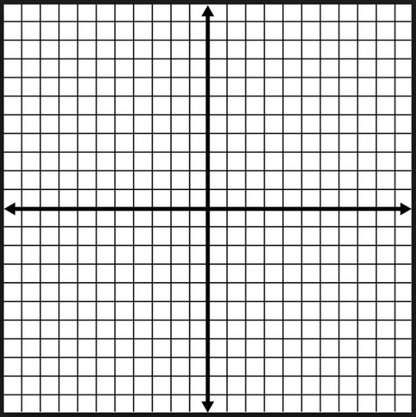

|  |
| --- |
| **Number of Turns:** |
| **Zeros:** |
| **Y-Intercept:** |
| **End Behavior:** |

**Example: Sketch a graph of the function**

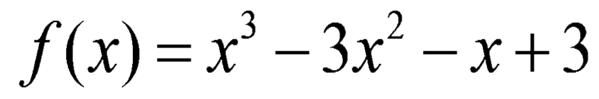

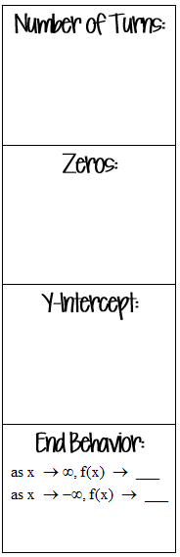

**Example: Sketch a graph of the function**



**Example: Sketch a graph of the function**



