**Polynomial Parent Functions**

There are several parent functions, however, we will only focus on the _________ and ________ parent functions. You will _______ start with one of these graphs _______ graphing with transformations!

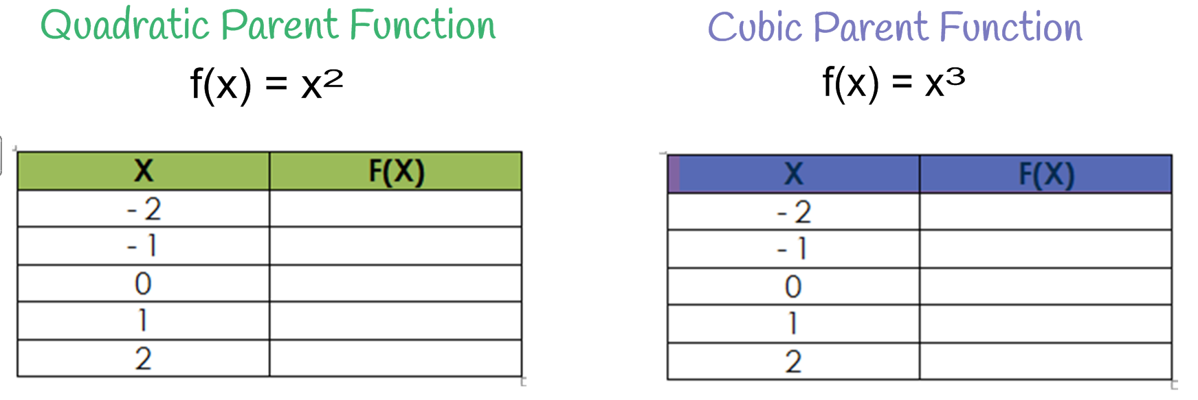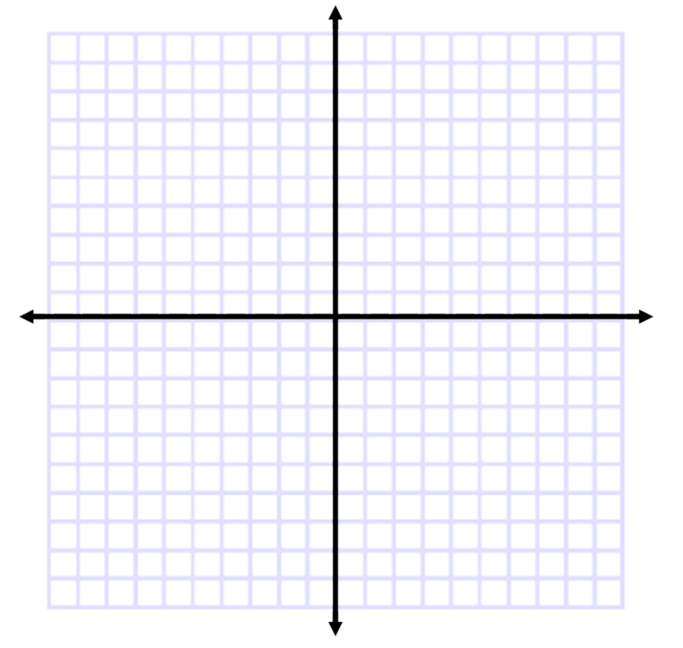

When performing transformations, ORDER MATTERS! You must apply __________ and then any ______. (Think about it like order of operations, you have to do multiplication before you can do addition, etc.)

**Transformations:**

**f(x) =__________________**

where # is any _______ number.

**Vertical Reflection Across the X-Axis**

f(x) = _(±x-c)#+d

* If the sign at the front of the function is negative, you have a reflection across the x-axis. So the portions of the graph that are ___, go _____, and the portions of the graph that are _____, go ___.

**Horizontal Reflection Across the Y-Axis**

f(x) = ±(_x-c)#+d

* If the sign in front of "x" is negative, you have a reflection across the y-axis. So the portions of the graph that are _____, go _____, and the portions of the graph that are _____, go _____.

**Horizontal Shift**

f(x) = ±(±x-_)#+d

* If c in the function is positive, HS _____ by ____.
* If c in the function is negative, HS _____by ____.

**Vertical Shift**

f(x) = ±(±x-c)#+_

* If d in the function is positive, VS ____ by ____.
* If d in the function is negative, VS ____ by ____.

**Example: Identify the parent function for the polynomial below. Then describe the transformations.**



|  |  |  |  |  |
| --- | --- | --- | --- | --- |
| **Parent Function:** | **Vertical Reflection?** | **Horizontal Reflection?** | **Horizontal Shift – Direction? How many?** | **Vertical Shift – Direction? How many?** |
|  |  |  |  |  |



|  |  |  |  |  |
| --- | --- | --- | --- | --- |
| **Parent Function:** | **Vertical Reflection?** | **Horizontal Reflection?** | **Horizontal Shift – Direction? How many?** | **Vertical Shift – Direction? How many?** |
|  |  |  |  |  |



|  |  |  |  |  |
| --- | --- | --- | --- | --- |
| **Parent Function:** | **Vertical Reflection?** | **Horizontal Reflection?** | **Horizontal Shift – Direction? How many?** | **Vertical Shift – Direction? How many?** |
|  |  |  |  |  |
| **Examples: Describe the transformations for  the given function and then graph using  transformations. Make sure to include the parent.** | | | | |
| |  |  |  |  |  | | --- | --- | --- | --- | --- | | **Parent Function:** | **Vertical Reflection?** | **Horizontal Reflection?** | **Horizontal Shift – Direction? How many?** | **Vertical Shift – Direction? How many?** | |  |  |  |  |  | | | | | |
| |  |  |  |  |  | | --- | --- | --- | --- | --- | | **Parent Function:** | **Vertical Reflection?** | **Horizontal Reflection?** | **Horizontal Shift – Direction? How many?** | **Vertical Shift – Direction? How many?** | |  |  |  |  |  | | | | | |