**A radical expression is made up of 3 parts:**

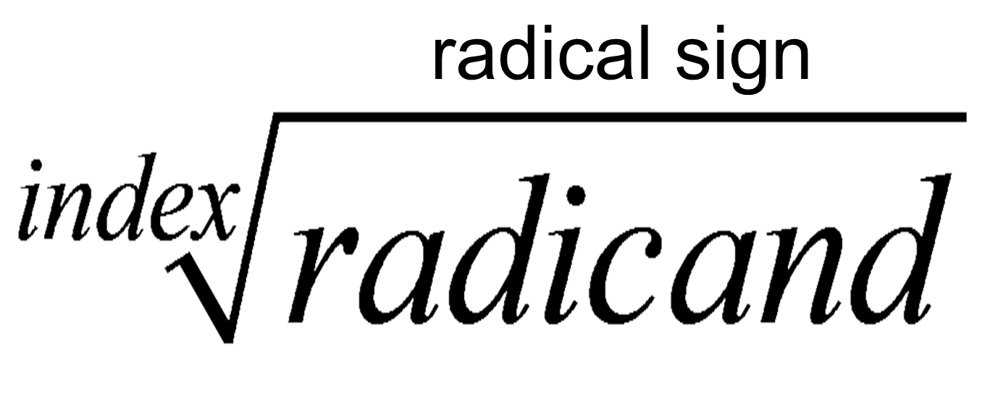

**To Simplify a Radical Expression:**

1.) Identify the ____________________.

2.) Break down the number under the radical into any 2 factors. Continue to break down factors until you reach all prime numbers. **_________________ ALL OF THE PRIME NUMBERS.**

3.) Use the index to determine **"how many of the same number you need in order to take ___________________ of those numbers to the outside of the radical."** Repeat this for all sets that you can make.

4.) **______________** all of the numbers you bring to the **_________________________** of the radical. Multiply any remaining numbers together on the inside.

5.) For any variables under the radical, take the **exponent and _________________ by the index.** The whole number of times it divides is the exponent to the variable on the _____________ of the radical and the remainder is the exponent to the variable on the _____________ of the radical.

**\*For any common variable on the outside of the radical, ___________ their exponents together.**

**Examples: Simplify completely.**

|  |  |  |  |
| --- | --- | --- | --- |
| 1.) | | 2.) | |
| 3.) | 4.) | |
| 5.) | 6.) | |