When dividing radical expressions, you MUST ______________ the ____________ from the ________________. All "_______________" numbers must be _____________________, as well as, any radical left in the numerator.

**How to divide radical expressions:**

Step 1: Rewrite the expression with _______________ radicals on __________ and __________________________.

Step 2: ______________________ the ________________________________.

Step 3: _______________________ the ___________________________. If the radical does not simplify out of the denominator, then you must _________________________ the denominator.

|  |
| --- |
| 1.) |

**How to Rationalize the Denominator:**

Step 1: _______________ the ________________ and ______________________ by "just enough" to eliminate the radical in the denominator. To find the "just enough" piece, take the _________________ and __________________ the ___________________________.

Step 2: _____________________ the radical in the numerator.

Step 3: Simplify any ________________________ terms.

**____________________ simplify an “inside” and “outside” together...or leave a radical in the denominator!**

**Examples: Simplify completely.**

|  |  |
| --- | --- |
| **2.)** | **3.)** |
| **4.)** | |

**Special Cases:**

When there is a radical being added or subtracted in the denominator, we must multiply by the __________________________________ in order to rationalize the denominator.

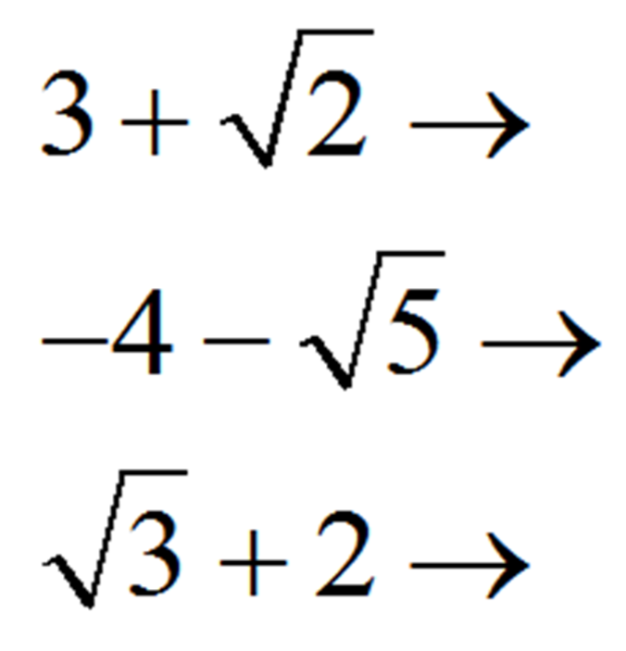

**Examples: Simplify completely.**

|  |  |
| --- | --- |
| 5.) | 6.) |