

|  |  |  |
| --- | --- | --- |
| **Transformation:** | **Will appear as ______** | **Example:** |
| Vertical Reflection |  |  |
| Horizontal Reflection |  |  |
| Horizontal Shift |  |  |
| Vertical Shift |  |  |

|  |  |  |  |  |  |  |  |  |  |  |  |  |  |  |  |  |  |  |  |  |  |  |  |
| --- | --- | --- | --- | --- | --- | --- | --- | --- | --- | --- | --- | --- | --- | --- | --- | --- | --- | --- | --- | --- | --- | --- | --- |
| **Square Root Functions**     |  |  | | --- | --- | | **X** | **Y** | |  |  | |  |  | |  |  | |  |  | | **Cube Root Functions**     |  |  | | --- | --- | | **X** | **Y** | |  |  | |  |  | |  |  | |  |  | |  |  | |

**Parent Functions:**

We will restrict our parent functions to square roots and cube roots.

**Example # 1: State the parent function & describe the transformation(s).**



|  |  |  |  |  |
| --- | --- | --- | --- | --- |
| **Parent Function:** | **Vertical Reflection:** | **Horizontal Reflection:** | **Horizontal Shift: Direction? How many?** | **Vertical Shift: Direction? How many?** |
|  |  |  |  |  |

**Example # 2: State the parent function & describe the transformation(s).**



|  |  |  |  |  |
| --- | --- | --- | --- | --- |
| **Parent Function:** | **Vertical Reflection:** | **Horizontal Reflection:** | **Horizontal Shift: Direction? How many?** | **Vertical Shift: Direction? How many?** |
|  |  |  |  |  |

**Graphing Radical Functions:**

1.) Graph the parent function.

2.) Move the parent function points based on the transformation to graph the function. Remember that order matters so move through the transformations from left to right from your table!

**Example # 3: Describe the transformations and then graph the function****. Include the parent function on your graph.**

|  |  |  |  |  |
| --- | --- | --- | --- | --- |
| **Parent Function:** | **Vertical Reflection:** | **Horizontal Reflection:** | **Horizontal Shift: Direction? How many?** | **Vertical Shift: Direction? How many?** |
|  |  |  |  |  |

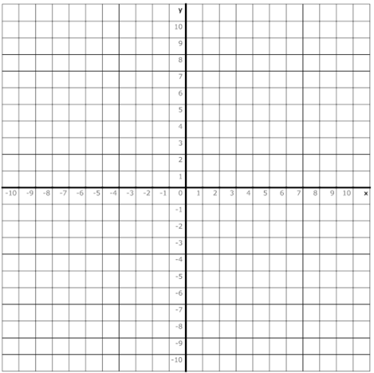

**Example # 4: Describe the transformations and then graph the function****. Include the parent function on your graph.**

|  |  |  |  |  |
| --- | --- | --- | --- | --- |
| **Parent Function:** | **Vertical Reflection:** | **Horizontal Reflection:** | **Horizontal Shift: Direction? How many?** | **Vertical Shift: Direction? How many?** |
|  |  |  |  |  |

