What it means to "factor?"
Take an __________ or _________ problem and write it as an EQUIVALENT _________ problem.

2 more ways to factor!
*____________
*Difference of Two Perfect Squares (___________)

Remember to always start by checking for a ____________ of the ENTIRE problem first!
We use A ≠ 1 when you have a ______________ ___________ whose leading coefficient is ____ 1.

How to factor using the A ≠ 1:
1.) Multiply "_____" x "_____" | 2.) Determine what ______ numbers multiply to "ac" that add up to "________"
3.) ____________ "b" as those 2 numbers (include the _____________). Bring down your original ___________ and _____________ terms.  Checkpoint: You should now have _________ terms! | 4.) Factor by ______________________.  - Put (first 2 terms)(last 2 terms)  - Factor out a GCF from each parenthesis.  GCF(leftovers) +/- GCF(leftovers)  *You must always take out Two GCF’s.  *The second GCF will have the same sign as the 3rd term.  *The second GCF may be a 1 or – 1.  Checkpoint: Your leftovers should be _________________!
Write your factors as (________)(_________)

Example: Factor using A $≠$ 1.
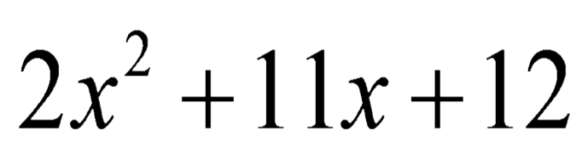

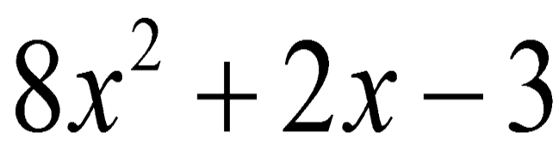

We use DOTS when you have...
________ Terms | 1 _________ Sign
Coefficients and Constants (all of the ____________) are Perfect Squares | Variables have ______ exponents  To factor variables, ________ the exponent by 2

How to factor using DOTS:

1.) Take the ____________________ of each term.
* DO __________ INCLUDE THE ____________ SIGN!

Write your factors as:
(___ + ___)(___ - ___)

The square root of the  positive term goes in ___________________. | The square root  of the term behind the minus sign goes in _______________.
Example: Factoring using DOTS.
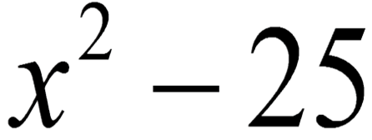 | 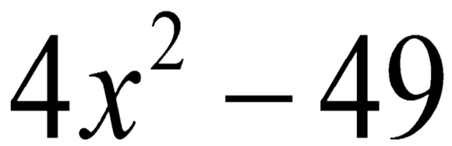

Putting it all together!

