**where ______ is the parent function.**

|  |  |  |
| --- | --- | --- |
| Transformation: | Will appear: | Description: |
| Reflection |  | Vertical Reflection across the _______ |
|  | Horizontal Reflection across the _______ |
| Vertical Shift |  | Vertical Shift _____ by ________. |
|  | Vertical Shift _____ by ________. |
| Horizontal Shift |  | Horizontal Shift _______ by ____. |
|  | Horizontal Shift _________ by ____. |

Example # 1: Identify the transformations for the functions below.

|  |  |  |  |  |
| --- | --- | --- | --- | --- |
|  | | | | |
| **Parent Function:** | **Vertical Reflection?** | **Horizontal Reflection?** | **Horizontal Shift: Direction? How many?** | **Vertical Shift: Direction? How many?** |
|  |  |  |  |  |

Example # 2: Identify the transformations for the functions below.

|  |  |  |  |  |
| --- | --- | --- | --- | --- |
|  | | | | |
| **Parent Function:** | **Vertical Reflection?** | **Horizontal Reflection?** | **Horizontal Shift: Direction? How many?** | **Vertical Shift: Direction? How many?** |
|  |  |  |  |  |

**Graphing Exponential Functions:**

**Step 1: Create the points (0, _) and (1, __).**

**Step 2: State and graph the asymptote (y = _).**

**Step 3: Plot the points from Step 1 and move based on the transformations.**

**Step 4: Connect the ___________________ with a smooth curve.**

**Example # 3: Graph the function using transformations.**

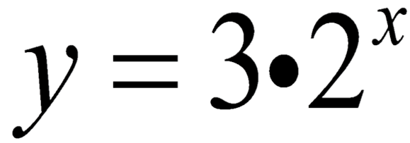

**Step 1: Create the points (0, a) and (1, ab).**

**Step 2: State & graph the asymptote (y = k).**

**Step 3: Plot the points from Step 1 and move based on the transformations.**

|  |  |  |  |
| --- | --- | --- | --- |
| **Vertical Reflection?** | **Horizontal Reflection?** | **Horizontal Shift: Direction? How many?** | **Vertical Shift: Direction? How many?** |
|  |  |  |  |

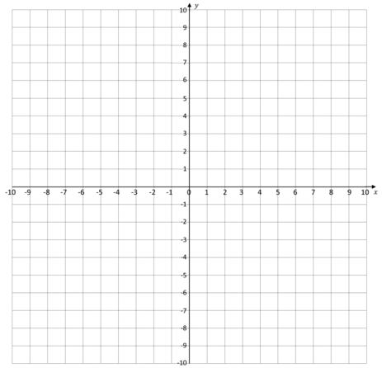

**Example # 4: Graph the function using transformations.**

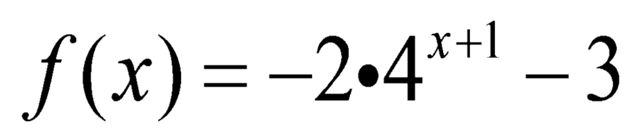

**Step 1: Create the points (0, a) and (1, ab).**

**Step 2: State & graph the asymptote (y = k).**

**Step 3: Plot the points from Step 1 and move based on the transformations.**

|  |  |  |  |
| --- | --- | --- | --- |
| **Vertical Reflection?** | **Horizontal Reflection?** | **Horizontal Shift: Direction? How many?** | **Vertical Shift: Direction? How many?** |
|  |  |  |  |

