**When solving exponential equations there are ___ scenarios that we can encounter...**

# 1 - solving exponential equations with ________________ bases

# 2 - solving exponential equations with __________ bases that can be _____________

**Solving Equations with Common Bases:**

If b is a positive number, other than 1, then

if and only if ___________.

This means that you can __________ out the bases and solve the equation using the terms _____________________ in the ________________!

**Example: Solve the equation (with common bases)**

|  |  |
| --- | --- |
|  |  |
|  |  |

**Solving Equations with Different Bases:**

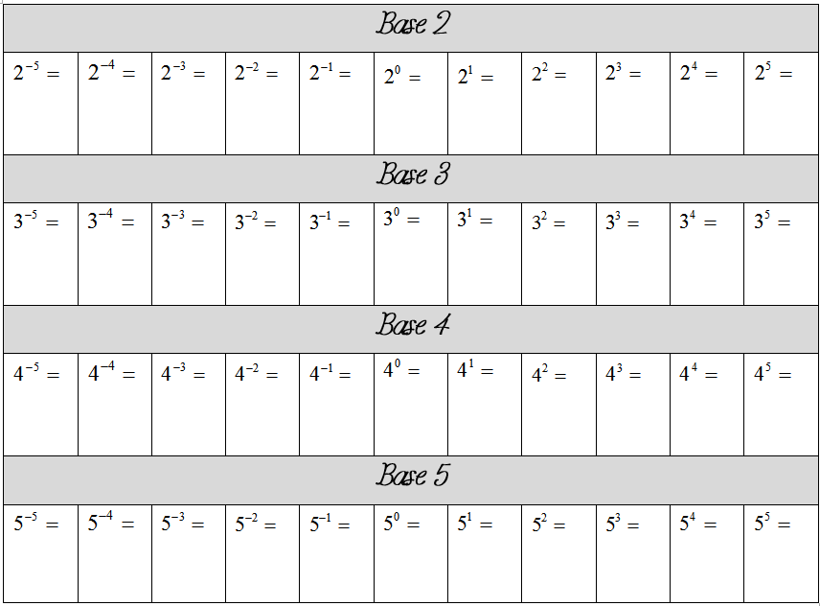

**Helpful Tips:**

*Check to see if the ___________________ base can be rewritten as the ________________ base.

*Check to see if both bases can be rewritten as the _________________________ number.

*Don’t forget to _______________ the “____________” exponent to all of the “_______________” exponent.

**Example: Solve the equation (by rewriting bases)**

|  |  |
| --- | --- |
|  |  |
|  |  |