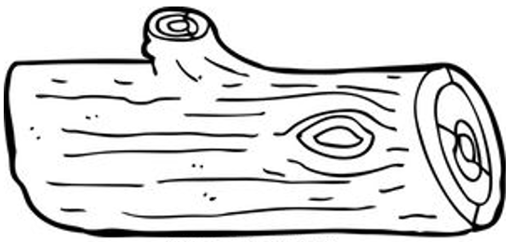

**LOGARITHMS**

Logarithms are the ___________ of exponential functions.

|  |  |
| --- | --- |
| **Exponential Form** | **Logarithmic Form** |
| **Example: Rewrite the exponential function in logarithmic form.** (See the “L” for Log)   |  |  | | --- | --- | | a.) | b.) | | c.) | d.)  Note: ___________________ | | | |
| **Example: Rewrite the logarithm in exponential form.**  (See the “e” for exponential)   |  |  | | --- | --- | | a.) | b.) | | c.)  Note: ___________________ | d.)  Note: ___________________ | | | |

**Evaluating Logs:**

|  |  |  |  |  |
| --- | --- | --- | --- | --- |
| Base 10: Plug directly into the calculator!  *If you have the TI-36 Pro, hit the “log” button **TWICE**.  **Example: Evaluate. Round any decimal answers to the hundredths place.**   |  |  | | --- | --- | | a.) | b.) | | c.) | d.) | |

Non-Base 10: Use the “change of base” formula to calculate!

*If you have the TI-36 Pro, hit the “log” button **3 times** and type in calculator without having to use formula.



**Example: Evaluate. Round any decimal answers to the hundredths place.**

|  |  |
| --- | --- |
| a.) | b.) |
| c.) | d.) |