**Dividing with Imaginary & Complex Numbers**

**Rules:**

*No i's in the _____________________________

*Make sure i's are in _________________ form…meaning nothing is ______________ than “____”

We saw in Keeper # 4, that sometimes the “i” in the denominator eliminates itself simply by subtracting exponents.

**Ex. # 1: Simplify completely.**

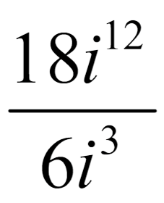

But what happens when there are no other “i’s” in the problem to do that? We must _________________________________________

to eliminate the “i.”

**Steps to Rationalizing the Denominator:**

1.) Simplify the “_______” completely

2.) _________________ the ______________ & _________________ by “i”

3.) ________________ the fraction completely

**Ex. # 2: Simplify completely.**

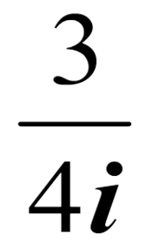

**Ex. # 3: Simplify completely.**



**Special Cases:**

When there is a complex number (real number + imaginary number) in the denominator, we must multiply by the ___________________________________ in order to rationalize the denominator.

**Complex Conjugates**

(What to multiply by in order to get rid of the "i")

**- 2 + 3i ---> ____________**

**1 - i ---> ______________**

**Ex. # 4: Simplify completely.**



**Ex. # 5: Simplify completely.**

