*Can be used to solve __________________ quadratic equation.

**How to Organize Your CTS Work**

**1)** Get equation in form $x^{2}+bx=$ constant

**2)** In left margin

 **3)** Lay out your work to prepare to “add-in” the “complete the square” term.

 = constant +



identical



**4)** “Add-in” the “complete the square” term.



 = constant +

**5)** Factor the left side and write as a **( ______)**.



**6)** Take the square root of both sides to **solve**. Remember when you take the square root of a number to include a  sign.

**Example: Solve by completing the square.**

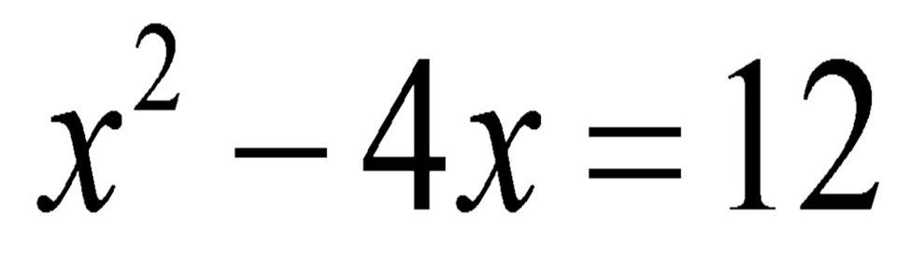

**Example: Solve by completing the square.**

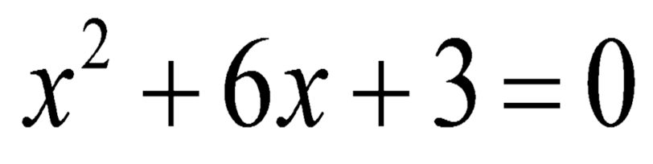

**Example: Solve by completing the square.**

