**The Quadratic Formula**

**The QF will _________ work when solving quadratic equations!**

1. Set equation = 0. Write exponents in descending order.

2. Identify a, b, and c.

3. Substitute a, b, and c in to the QF and simplify completely.

**The Discriminant**

Is the expression under the radical. It tells us

_______________________________________________________

the quadratic equation has.

**If is...**

**\*a Positive number = ___________________________**

**\*Zero = ____________________________________**

**\*a Negative number = _____________________________**

**Example: Determine the discriminant and state the number and types of solutions.**

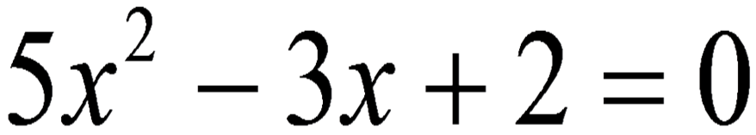

**Example: Solve using the Quadratic Formula.**



**Example: Solve using the Quadratic Formula.**



**Example: Solve using the Quadratic Formula.**

