To divide using Synthetic Division the divisor must be a ______________________________ with a ________________________________________________.
or

What does synthetic division look like?
1.) Set the divisor = 0 and solve. Use this value to place in the box.
2.) Take the dividend, written in standard form and with any necessary “place holders” for missing exponents, and list the coefficients. *Don’t forget your signs!
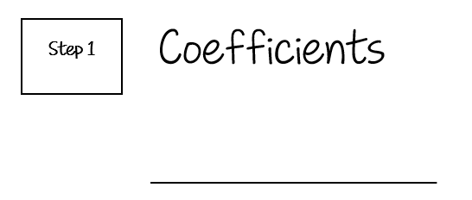
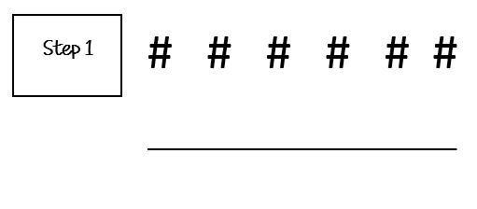
3.) Bring down the 1st coefficient under the line.

#

4.) Multiply the coefficient under the line by the number in your box and place it above the line under the next coefficient.
#

#
5.) Add the two numbers together and bring the new number under the line.
#
#
#

6.) Repeat Steps 4 & 5 until all numbers have been multiplied and columns have been added.
What does my answer look like?
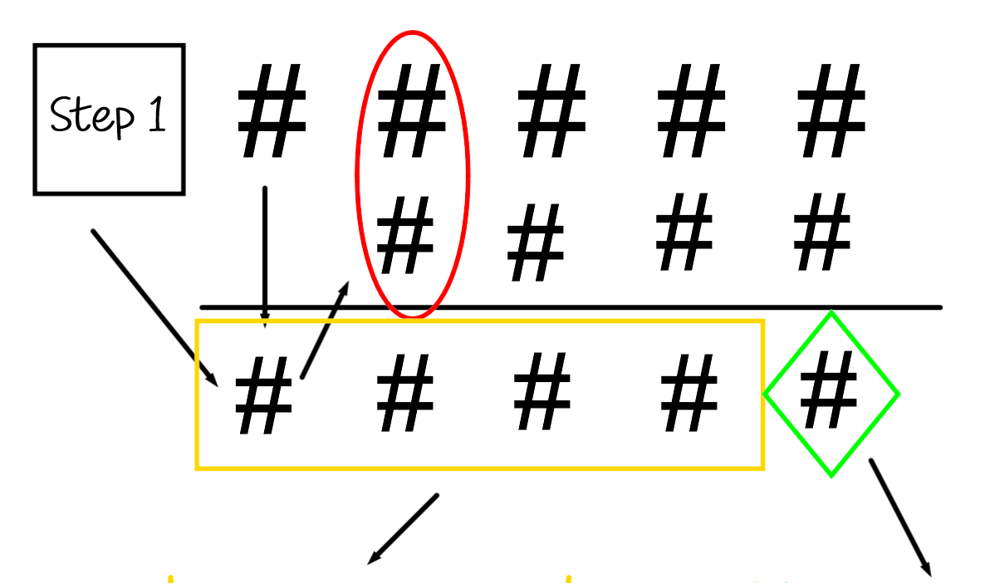

The degree of your quotient will always be ____________________________ than the degree of your dividend.

*It should look the _________________________ as it did when we used long division.
Example: Divide using Synthetic Division.
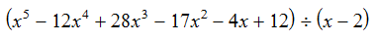

Example: Divide using Synthetic Division.

