Honors Algebra 2 Name: ________________________________________
Synthetic Division Date: _______________________ Block: _______

Use synthetic division to divide each polynomial.
1.) 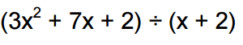 | 2.) 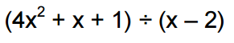
3.) 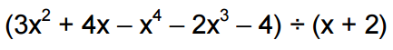 | 4.) 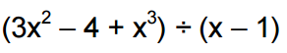
5.) 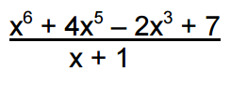 | 6.) 