When factoring polynomials, there are 3 methods we will encounter:
*Special Quadratics
*Sum or Difference of Special Cubes
*Grouping

Remember...EVERY time you factor ______________________________!!!!! Place in the front of your final answer.
Then look at the "leftovers" to see if you can factor using another method.

Use "Special Quadratics" when you have...

*_______ Terms
*Leading coefficient = _____________
*Degree = _____________________________________
Note: The "bx" term will have an exponent that is ___________________ the degree.

Factor these just like we did ________________________________ except the x's will have a different exponent.

Steps:
1.) Find two numbers that multiply to "c" that sum up to "b."

What will my answer look like?

*Remember there are _____ possible sign combinations for these!

Example: Factoring using Special Quadratics.
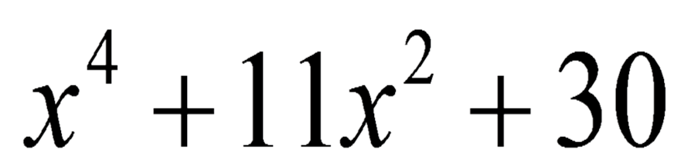 | 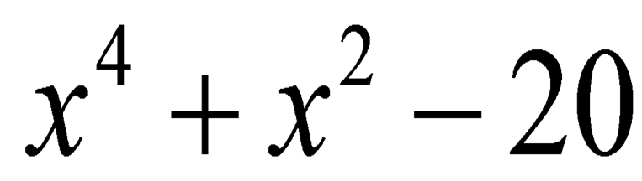
Use "Sum or Difference of Special Cubes" when you have...

*_________ Terms
*Coefficients and Constants are Perfect __________
*Variables have exponents that are multiples of __
**To factor variables, ______ the exponent by 3

Steps:
1.) Take the cube root of the 1st term & 2nd term.

What will my answer look like?
Your answer will depend on whether the original polynomial was a sum or difference:
Sum | Difference

To help you remember the signs for factoring Special Cubes, think ___________!

Same Opposite Always Positive
Example: Factoring using Special Cubes.
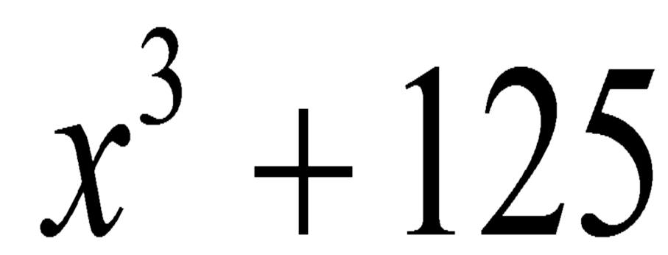 | 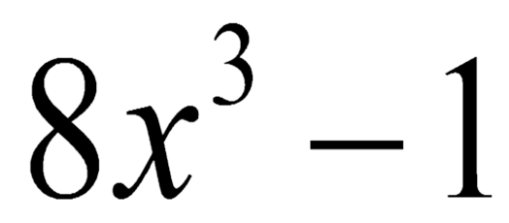

Use "grouping" when you have...

*_____________ terms
*______________ GCF

Steps:
1.) Put (first 2 terms)(last 2 terms)
2.) Factor out a GCF from each parenthesis.
GCF(leftovers) +/- GCF(leftovers)
*For the second GCF, take out the same sign as the 3rd term.
You may need to take out a 1 or - 1 for the second GCF.
*Your leftovers should be identical!
3.) Write your factors as (GCF's)(leftoveR)

Example: Factoring using Grouping.
