**In order to sketch the graph of a polynomial function, we need _______ characteristics:**

|  |
| --- |
| **Number of Turns** |
| *How many turns the graph has.  ________________ - __________ |
| **End Behavior** |
| |  |  |  | | --- | --- | --- | |  | **Even Degree** | **Odd Degree** | | **+ LC** |  |  | | **- LC** |  |  |   *What f(x) does as we choose larger positive and larger negative x-values. |
| **Finding Zeros** |
| *The values of x where the graph crosses the x-axis.  **Steps to finding zeros in the calculator:**   1. Select “Table” 2. Select # 2 - “Edit Function” 3. Enter the polynomial function and press “Enter” 5 times until a table of values appears. 4. Scroll through the table to determine the values of x when y = 0.   *Remember your degree = the number of solutions.  **What happens is one (or more) of the zeros doesn’t appear in our table?**  1.) Use synthetic division to divide out the zeros you can find.  2.) Solve the resulting polynomial to determine the remaining zeros. |
| **Y-Intercept** |
| *The point where the graph crosses the y-axis. The y-int. is always written as the point (0, y).  To calculate the y-intercept, plug in ZERO for x and simplify. **HINT:** This should result in the CONSTANT value of the polynomial. |

**Example: Sketch a graph of the function**

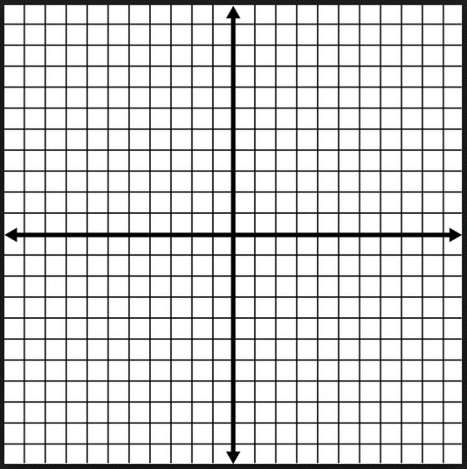

|  |
| --- |
| **Number of Turns:** |
| **Zeros:** |
| **Y-Intercept:** |
| **End Behavior:** |

**Example: Sketch a graph of the function**



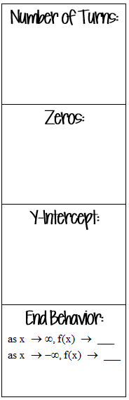

**Example: Sketch a graph of the function**



**Example: Sketch a graph of the function**



