Honors Algebra 2 Name:_____________________________________

Sketching Polynomials Date:_____________________ Block:_____

**Complete the information in the table to sketch the graph.**

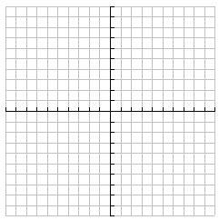1. $f\left(x\right)=-x^{3}-3x^{2}+x+3$

|  |
| --- |
| **Number of Turns:** |
| **Zeros:** |
| **y-intercepts:** |
| **End Behavior:** |

2 $f\left(x\right)=x^{4}+2x^{3}-8x^{2}-18x-9$

|  |
| --- |
| **Number of Turns:** |
| **Zeros:** |
| **y-intercepts:** |
| **End Behavior:** |

3. 

|  |
| --- |
| **Number of Turns:** |
| **Zeros:** |
| **y-intercepts:** |
| **End Behavior:** |

4. 

|  |
| --- |
| **Number of Turns:** |
| **Zeros:** |
| **y-intercepts:** |
| **End Behavior:** |

