When dividing radical expressions, you MUST _________________ the ______________ from the _____________________. All "___________________" numbers must be ____________________, as well as, any radical left in the numerator.

There are several scenarios when dividing radical expressions. The first one is when we are given _______________ radical with a ____________________________ underneath.

Step 1: Use the Quotient Property of Radicals to rewrite the expression. This property allows you to write a fraction under one big radical as the numerator and denominator under separate radicals.

**Step 2:** Simplify the numerator.

**Step 3:** Simplify the denominator.

**Example: Simplify completely.**

|  |
| --- |
| **1.)** |

**What if the radical in the denominator does NOT eliminate when we simplify?**

You must _________________________________________________________!

*Think about how many of the number/variable we have in the denominator and how many more you need to match the index.

Let's call this "just enough."

**Step 1:** Multiply the numerator and denominator by "just enough" to eliminate the radical in the denominator.

**Step 2:** Simplify the radical in the numerator.

**Step 3:** Simplify any outside terms.

**Remember you can NEVER simplify an “inside” and “outside” together!**

**Examples: Simplify completely.**

|  |  |
| --- | --- |
| **2.)** | **3.)** |
| **4.)** | **5.)** |

**Special Cases:**

When there is a radical being added or subtracted in the denominator, we must multiply by the __________________________________ in order to rationalize the denominator.

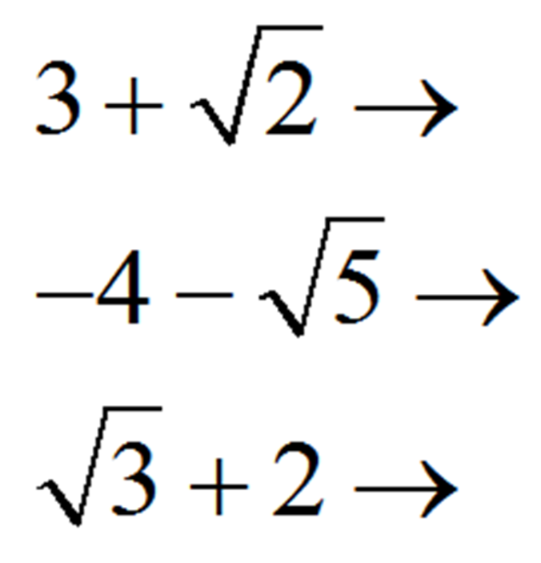

**Examples: Simplify completely.**

|  |  |
| --- | --- |
| 6.) | 7.) |