**We are going to focus on the following characteristics of radical functions:**

Domain & Range

Intercepts

Intervals of Increase/Decrease

Absolute Maximum/Minimum

End Behavior

**Domain & Range**

|  |  |
| --- | --- |
| **Domain** - all of the x-values that can go ____________ the function. | **Range** - all of the y-values you can get ______________ of the function. |
| **Even Index:**  **Domain** - Set the expression ___________________ the square root **greater than or equal** **to** zero and ________________..  **Range** - Use the y-coordinate from the ______________________ value to help you determine the range.  *If the graph goes ________________ the minimum/maximum value, then the range will be **y ____ y-coordinate**  *If the graph goes ____________ the minimum/maximum value, then the range will be **y ____y-coordinate** | |
| **Odd Index:**  **Domain** - ________________________  **Range** - ________________________ | |

**Intercepts**

|  |  |
| --- | --- |
| **\*x-intercept** - the point (______). You can find the value of x by plugging in zero for y and solving. | **\*y-intercept** - the point (______). You can find the value of y by plugging in zero for x and solving. |

**Intervals of Increase/Decrease**

|  |  |
| --- | --- |
| **\*Intervals of Increase** - the x-values of the graph where it goes __________ from left to right. | **\*Intervals of Decrease** - the x-values of the graph where it goes _________ from left to right. |
| **If the graph stops at the x-value, use _______.**  **If the graph continues at the x-value, use ______.** | |

**Absolute Maximum/Minimum**

|  |  |
| --- | --- |
| **\*Absolute Maximum** - the _________ point on the graph. If this point is infinity, then there is _____ absolute maximum. | **\*Absolute Minimum** - the ________ point on the graph. If this point is infinity, then there is _______ absolute minimum. |

**End Behavior:**

Describes what f(x) does if you could follow the graph FOREVER!

|  |  |
| --- | --- |
| If your arrow points to the right... | If your arrow points to the left... |

**Example # 1:** Describe the characteristics for the function 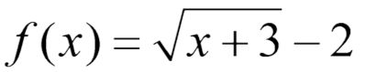given by the graph below.

|  |
| --- |
|  |
| Domain: ____________  Range: ____________  x-intercept: ____________ y-intercept: ____________  Intervals of Increase: ____________  Intervals of Decrease: ____________  Absolute Minimum: ______ Absolute Maximum: _____  End Behavior: |

**Example # 2:** Describe the characteristics for the function 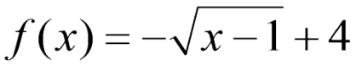 given by the graph below.

|  |
| --- |
|  |
| Domain: ____________  Range: ____________  x-intercept: ____________ y-intercept: ____________  Intervals of Increase: ____________  Intervals of Decrease: ____________  Absolute Minimum: ______ Absolute Maximum: _____  End Behavior: |

**Example # 3:** Describe the characteristics for the function 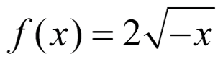 given by the graph below.

|  |
| --- |
|  |
| Domain: ____________  Range: ____________  x-intercept: ____________ y-intercept: ____________  Intervals of Increase: ____________  Intervals of Decrease: ____________  Absolute Minimum: ______ Absolute Maximum: _____  End Behavior: |

**Example # 4:** Describe the characteristics for the function 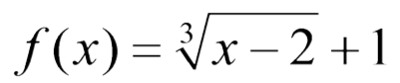given by the graph below.

|  |
| --- |
|  |
| Domain: ____________  Range: ____________  x-intercept: ____________ y-intercept: ____________  Intervals of Increase: ____________  Intervals of Decrease: ____________  Absolute Minimum: ______ Absolute Maximum: _____  End Behavior: |