

|  |  |  |
| --- | --- | --- |
| **Transformation:** | **Will appear as ______** | **Example:** |
| Vertical Reflection |  |  |
| Horizontal Reflection |  |  |
| Vertical Stretch |  |  |
| Vertical Shrink |  |  |
| Horizontal Stretch |  |  |
| Horizontal Shrink |  |  |
| Horizontal Shift |  |  |
| Vertical Shift |  |  |

**Example # 1: State the parent function & describe the transformation(s).**

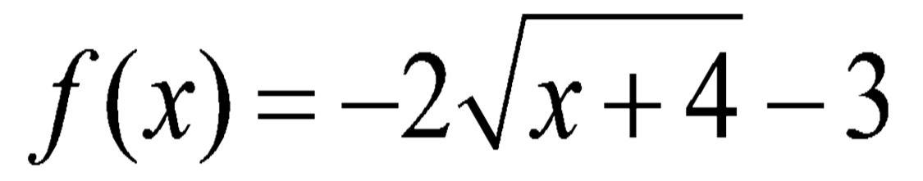

|  |  |  |  |  |  |  |  |  |
| --- | --- | --- | --- | --- | --- | --- | --- | --- |
| **Parent Function:** | **Vertical Reflection:** | **Horizontal Reflection:** | **Vertical Stretch by?** | **Vertical Shrink by?** | **Horizontal Stretch by?** | **Horizontal Shrink by?** | **Horizontal Shift: Direction? How many?** | **Vertical Shift: Direction? How many?** |
|  |  |  |  |  |  |  |  |  |

**Example # 2: State the parent function & describe the transformation(s).**



|  |  |  |  |  |  |  |  |  |
| --- | --- | --- | --- | --- | --- | --- | --- | --- |
| **Parent Function:** | **Vertical Reflection:** | **Horizontal Reflection:** | **Vertical Stretch by?** | **Vertical Shrink by?** | **Horizontal Stretch by?** | **Horizontal Shrink by?** | **Horizontal Shift: Direction? How many?** | **Vertical Shift: Direction? How many?** |
|  |  |  |  |  |  |  |  |  |

**Graphing Radical Functions:**

1.) Identify the parent function. (We will restrict our parent functions to square roots and cube roots) and plot their points.

|  |  |  |  |  |  |  |  |  |  |  |  |  |  |  |  |  |  |  |  |  |  |  |  |
| --- | --- | --- | --- | --- | --- | --- | --- | --- | --- | --- | --- | --- | --- | --- | --- | --- | --- | --- | --- | --- | --- | --- | --- |
| **Square Root Functions**     |  |  | | --- | --- | | **X** | **Y** | |  |  | |  |  | |  |  | |  |  | | **Cube Root Functions**     |  |  | | --- | --- | | **X** | **Y** | |  |  | |  |  | |  |  | |  |  | |  |  | |

2.) Move the parent function points based on the transformation to graph the function. Remember that order matters so move through the transformations from left to right from your table!

**Example # 3: Describe the transformations and then graph the function** **. Include the parent function on your graph.**

|  |  |  |  |  |  |  |  |  |
| --- | --- | --- | --- | --- | --- | --- | --- | --- |
| **Parent Function:** | **Vertical Reflection:** | **Horizontal Reflection:** | **Vertical Stretch by?** | **Vertical Shrink by?** | **Horizontal Stretch by?** | **Horizontal Shrink by?** | **Horizontal Shift: Direction? How many?** | **Vertical Shift: Direction? How many?** |
|  |  |  |  |  |  |  |  |  |

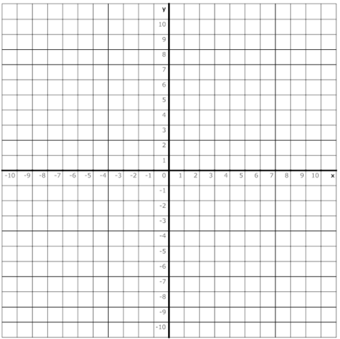

**Example # 4: Describe the transformations and then graph the function****. Include the parent function on your graph.**

|  |  |  |  |  |  |  |  |  |
| --- | --- | --- | --- | --- | --- | --- | --- | --- |
| **Parent Function:** | **Vertical Reflection:** | **Horizontal Reflection:** | **Vertical Stretch by?** | **Vertical Shrink by?** | **Horizontal Stretch by?** | **Horizontal Shrink by?** | **Horizontal Shift: Direction? How many?** | **Vertical Shift: Direction? How many?** |
|  |  |  |  |  |  |  |  |  |

