**How do we solve radical equations?**

1.) ____________ the radical on one side of the equation.

2.) Raise **_____________** of the equation to the nth power.

*(nth power = _______ value)*

3.) Simplify and solve.

4.) Check your solution(s) for extraneous solutions.

**\*Solutions that cause the equation to be ____________.**

**Examples: Solve. Remember to check for extraneous solutions.**

|  |  |
| --- | --- |
| 1.) | 2.) |
| 3.) | 4.) |
| 5.) | |

**How do we solve equations with rational exponents?**

1.) Isolate the on one side of the equation.

2.) Raise **BOTH SIDES** of the equation to the ______ of rational exponent.



3.) Simplify and solve.

4.) Check your solution(s) for extraneous solutions.

**Examples: Solve. Remember to check for extraneous solutions.**

|  |  |
| --- | --- |
| 6.) | 7.) |

**How do we solve equations with whole number exponents?**

1.) Isolate the 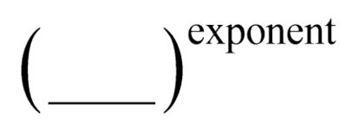.

2.) Nth root both sides using the exponent value.

(nth root = __________ value)

*Any time you apply a ________________, you must add a _______ in front of your answer.

Your exponent, called the ________________, will **______________** the number of solutions.

**Examples: Solve the equation.**

|  |  |
| --- | --- |
| **8.)** | **9.)** |
| **10.)** | |

When applying radical functions, we use their properties to solve real-world problems. To do this, we generally **__________________** in given information into the equation and **_________________** for the required variable.

**Example 11:**

The formula  represents the swing of a pendulum. S is the time in seconds to swing back and forth, and L is the length of the pendulum in feet. Find the length of a pendulum that makes a single swing in 2.5 seconds. (Round your answer to 3 decimal places.)