2 more ways to factor!
*____________
*Difference of Two Squares (___________)
Remember to always start by checking for a ____________ of the ENTIRE problem first!

We use A ≠ 1 when you have a ______________
___________ whose leading coefficient is ____ 1.

How to factor using A ≠ 1:
1.) Multiply ________________ | 2.) Determine what 2 numbers ________________ to "ac" that ___________ to "b"
3.) ____________ "b" as those 2 numbers (include the variable). Bring down the original _______________ and _______________ terms.  You should now have 4 terms! | 4.) Factor by grouping.  - The second GCF should be the _____________ sign as the 3rd term.  - You must take out a second GCF, which may end of being a ___ or ___.  - Your “leftovers should be ______________!
*Write your factors as (________)(_________)

Example: Factor using A $≠$ 1.
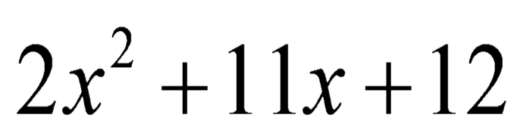 | 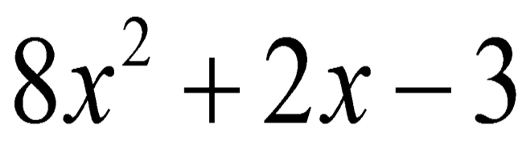
We use DOTS when you have...
*______ Terms
*1 ________ Sign
*Coefficients and Constants are _________________
*Variables have ____________ exponents
To factor variables, _______ the exponent by _____

How to factor using DOTS:

How to factor using DOTS:
1.) Take the _______________________ of each term.
*Do NOT include the ___________ sign!

Write your factors as:
(_________)(________)

The square root of the  positive term goes in ___________________. | The square root  of the term behind the minus sign goes in _______________.

Example: Factoring using DOTS.
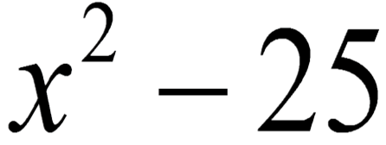 | 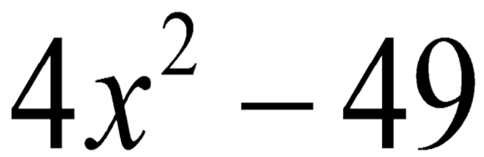
What do you think about…

