**Steps to Multiplying Rational Expressions**

1.) Factor each numerator & denominator.

2.) "_________" all of the factors on the ______ together and all of the factors on the ___________ together.

3.) _________ by _____________ out common factors from the ____________ & _____________... remember, only __for __!

4.) Write your answer in simplest __________ form...**DO _____________ DISTRIBUTE!**

Examples: Multiply

|  |  |
| --- | --- |
| 1.) | 2.) |

**Steps to Dividing Rational Expressions**

1.) ____________ as ___________ by the _____________________.

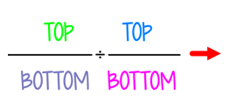

**Remember ______, _______, ____!**

2.) Follow steps for ____________ Rational Expressions.

Examples: Divide

|  |
| --- |
| 3.) |
| 4.) |