A complex rational expression is simply a fraction ___________ another fraction.

Complex ____ Difficult

Simplifying Complex Rational Expressions:
1.) Simplify the numerator down to _______________ fraction.

2.) Simplify the denominator down to _______________ fraction.

3.) Multiply by the ___________________.
"Keep, change, flip"

4.) Follow the steps for ___________________ rational expressions.

REMEMBER TO WRITE YOUR ANSWER IN SIMPLEST __________________ FORM!
Examples: Simplify.
1.) 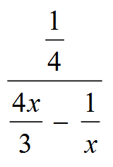

2.) 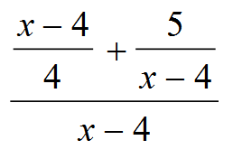

3.) 