When we talk about rational expressions, we must discuss the potential of __________________________________________.

These are the values of "x" that can cause ___________ in the denominator…
regardless of the ability to simplify.

To find these values, _____________ the denominator and set each factor ______________ to zero and ____________.

Find excluded values ______________________ you simplify!

Example: Find the excluded values for the rational expression and then simplify.
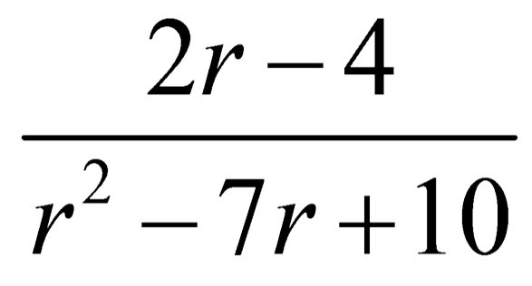

Steps to Solving Rational Equations
1.) _______________ each of the _______________________.

2.) _____________ each numerator by its __________________ factors.
*Use the table to help you determine.

3.) __________________ out the _________________ and ______________ using the _________________________.

4.) Check for ____________________________ solutions.

*If a solution causes zero in the denominator, we call the solution EXTRANEOUS.

*If all of the solutions are extraneous, the equation has ___________________________.

Example: Solve.
