Characteristics:
May have ____________________. This is a line that the function approaches more and more closely, but doesn't ever touch.

For a rational function of the form,
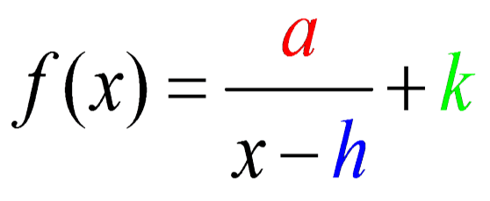

There is a _________________________ at the line x = _____, and the domain is _________________________.

(All of the x-values, except when x = h)

There is a _________________________ at the line y = _____, and the range is _________________________.

(All of the y-values, except when y = k)

Example # 1: Describe the transformations and identify the asymptote(s), domain, and range for the function:
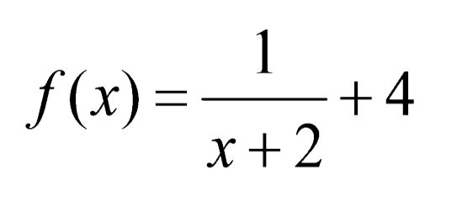

Vertical Asymptote: ______________________
Horizontal Asymptote: ____________________
Domain: ____________________________
Range: ____________________
Zeros and Asymptotes:

If __________________, where p and q are polynomial functions written in standard form with no common factors other than 1, then the function f(x) has
- zeros at each real value of x for which _____________________.
- a vertical asymptote at each real value of x for which __________.
- a horizontal asymptote based on the degree of p(x) and q(x).
- If the degree of p _____ degree of q, there is _____ horizontal asymptote.
- If the degree of p _____ degree q, the horizontal asymptote is the line _______________.
- If the degree of p ______ degree of q, the horizontal asymptote is the line

Some rational functions may actually ______________ the horizontal asymptote!
Example # 2: Identify the zeros and asymptotes for the function below.
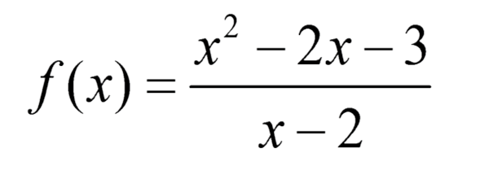

Step 1: Factor the numerator and denominator.

Step 2: Set each factor in the numerator equal to zero and solve to find the zeros of the function.

Step 3: Set each factor in the denominator equal to zero and solve to find the vertical asymptote(s).

Step 4: Compare the degree of p(x) to the degree of q(x) to determine the horizontal asymptote.

Example # 3: Identify the zeros and asymptotes of the function below.
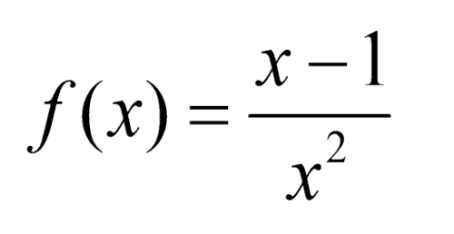

Step 1: Factor the numerator and denominator.

Step 2: Set each factor in the numerator equal to zero and solve to find the zeros of the function.

Step 3: Set each factor in the denominator equal to zero and solve to find the vertical asymptote(s).

Step 4: Compare the degree of p(x) to the degree of q(x) to determine the horizontal asymptote.

In some cases, both the numerator and denominator of a rational function will equal 0 for a particular x-value. As a result, the function will be undefined at this x-value. When this happens, the graph of the function may have a ____________. A hole is an __________________________ point(s) in a graph.

Holes in Graphs:
If a rational function has the same factor ______________ in both the numerator and denominator, then there is a hole in the graph at the point where ______________, unless the line x = b is a _________________ asymptote.

Example # 4: Identify the holes in the graph below.
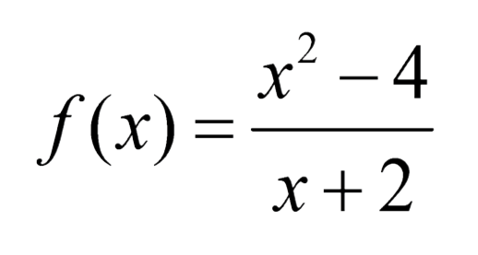

Step 1: Factor the numerator and denominator.

Step 2: Identify common factors in the numerator and denominator.

Step 3: Set the common factor equal to zero and solve.

Step 4: Substitute the holes x-value in to the remaining factors of the function and simplify to find your y-value.

