Transformations:
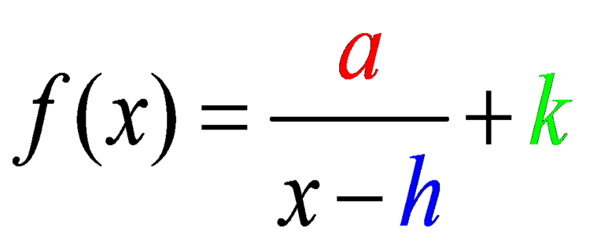

______________________________ - If ______________________.

_____________________________ - depends on the value of ____
- If _____________ it shifts to the ______________.
- If _____________ it shifts to the ______________.

_____________________________ - depends on the value of ____
- If _____________ it shifts __________________.
- If _____________ it shifts __________________.

Example # 1: Describe the transformations for the function below.
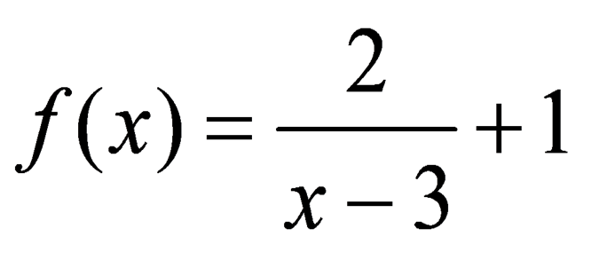

Vertical Reflection? | Horizontal Shift: Direction? How many? | Vertical Shift: Direction? How many?
Graphing:
The graph of a rational function is a __________________, which has two separate branches.
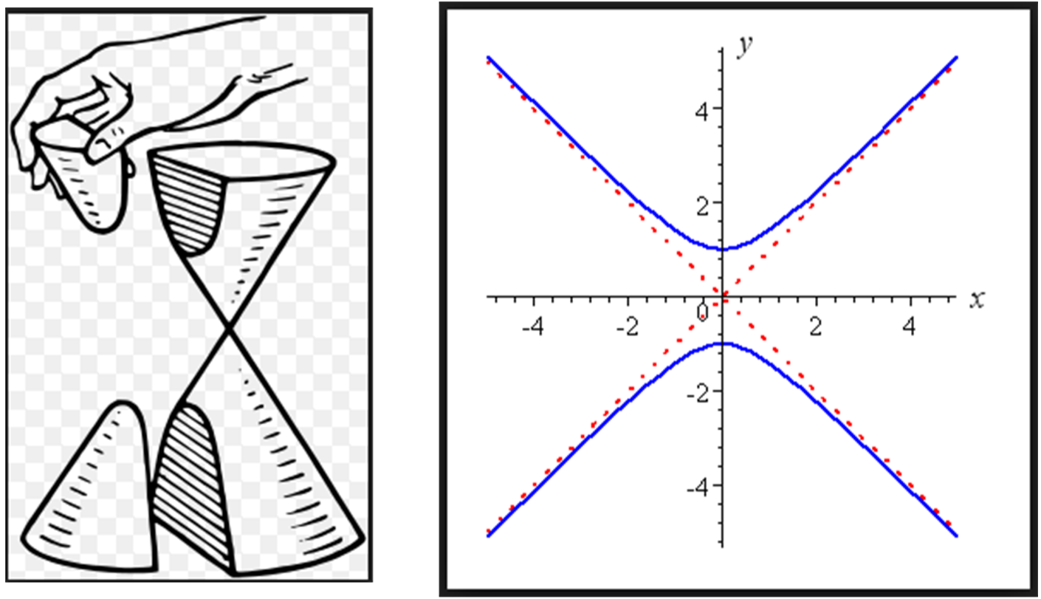

Steps to Graphing Rational Functions:
1.) Find the ____________.
2.) Identify and graph the ___________.
3.) Create a __________ of values.
*You can use the table feature in your calculator.
*Make sure to ___________ your zeros as well as x-values on the left and right of each of them and the asymptotes...both positive and negative numbers!
4.) ______________ the points from your table.
5.) Connect with a smooth curve.
Example # 2: Graph.
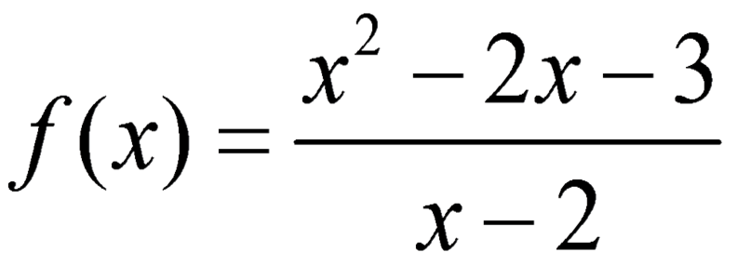

We already determine that the ZEROS of the function are x = ____ and x = ____and the ________ ASYMPTOTE is ____________.

Table of Values: | Draw the asymptote(s), plot the points from your table, and connect your points with a smooth curve.  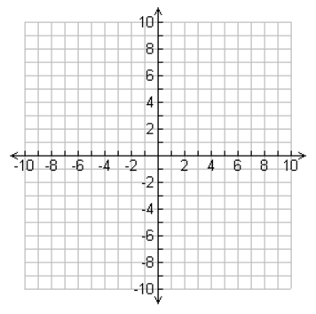

Example # 3: Graph
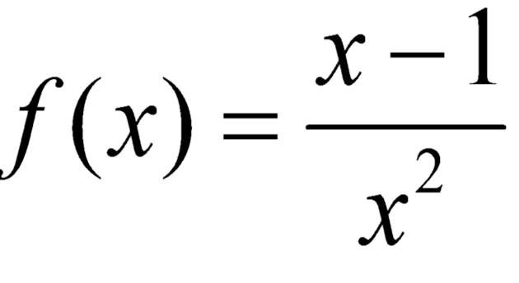

We determined that the ZEROS of the function are x = ____ and the ________ ASYMPTOTE is _____ and the ___________ ASYMPTOTE is _____

Table of Values: | Draw the asymptote(s), plot the points from your table, and connect your points with a smooth curve.
Example # 4: Identify the holes in the graph below. Then graph.
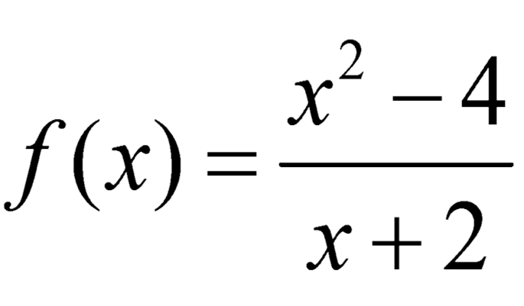
We determined that the HOLE occurs at the point ______.

To Graph Functions with Holes:
Depending on the remaining function, you can graph using a table of values or slope-intercept form.

Our remaining function is f(x) = _____ which we know is the same as ______ so we can graph using slope intercept form.
Don't forget to leave a HOLE at the point _______!

Table of Values:

