|  |  |  |
| --- | --- | --- |
| Transformation: | Notation: | Description: |
| Reflection |  | Vertical Reflection across the _______ |
|  | Horizontal Reflection across the _______ |
| Vertical Stretch | *if _____________ | Vertical Stretch by a factor of _______. |
| Vertical Shrink | *if _____________ | Vertical Shrink  by a factor of ____. |
| Horizontal Stretch | *if _____________ | Horizontal Stretch by a factor of ______. |
| Horizontal Shrink | *if ______________ | Horizontal Shrink by a factor of _______. |
| Horizontal Shift |  | Horizontal Shift _____ by ________. |
|  | Horizontal Shift _____ by ________. |
| Vertical Shift |  | Vertical Shift _______ by ____. |
|  | Vertical Shift _________ by ____. |

**Examples:** Identify the transformations for the functions below.



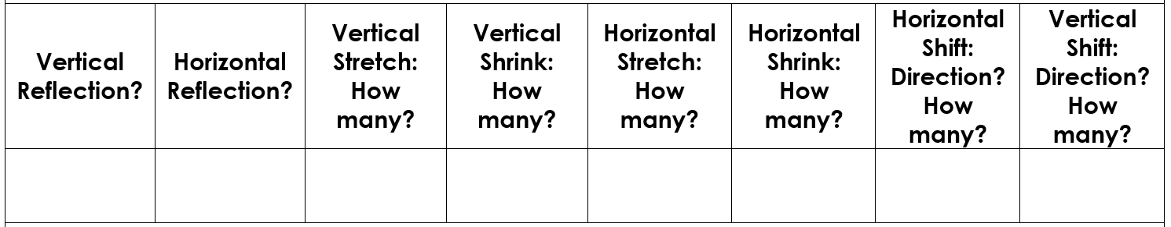





**Example:** Write the equation of an exponential function with a base of 8 that has been vertically reflected, vertically compressed by 1/3, horizontally shifted left 4, and vertically shifted up 2.

**Example:** Write the equation of an exponential function with a base of 2 that has been horizontally reflected, vertically stretched by 3, horizontally compressed by 1/2, and vertically shifted down 2.

**Steps to Graphing Exponential Functions:**

Step 1: Create the points (0, _) and (1, __).

Step 2: Identify & graph the asymptote (y = _).

Step 3: Plot the points from Step 1 and move based on the transformations. Remember order matters!

Step 4: Connect the ___________________ with a smooth curve.

**Example:** Graph the function using transformations.







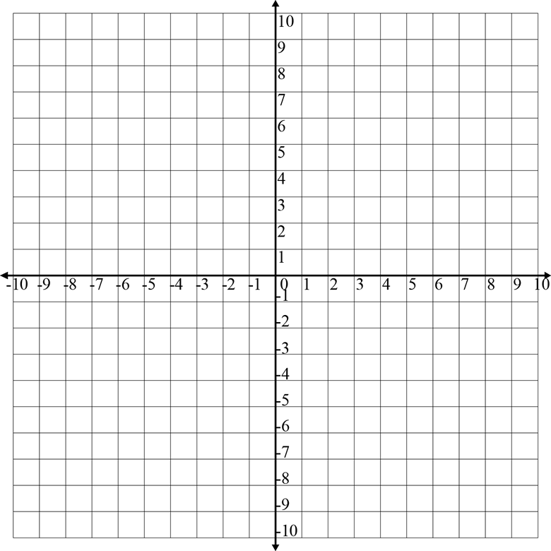

**Example:** Graph the function using transformations.







