Inverse Functions

Step 1: Replace f (x) with _______

Step 2: ____________ x and y

Step 3: _______________ for y

Step 4: Replace y with ______________ to indicate the inverse function

Example: Find the inverse function for f(x).
f (x) = 2x – 3

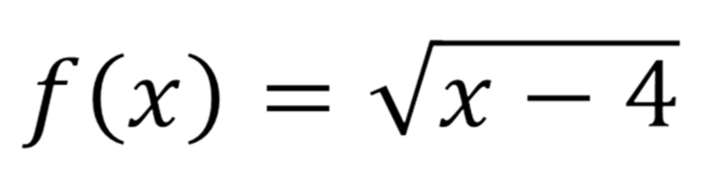

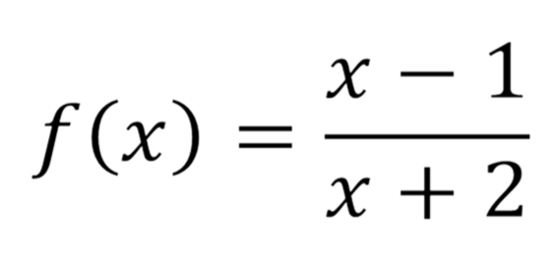

We can verify two functions are inverses of one another by using ___________________ (remember this is a function inside of another function).

To __________ inverses:
1.) compose ________

2.) compose ________

If ______ compositions result in "____" then the two functions are
inverses of one another.
Example: Verify that two functions are inverses using compositions of functions.
