**What is an imaginary number?**

A number "i" that, when squared, results in a _____________.

Defined as i = ___.

If i = __, then...

 = _____________

 = _____________

 = _____________

 = _____________

 = _____________

What do you think happens with ?

What does this mean about imaginary numbers?

**How could you simplify imaginary numbers with any exponent?**

*Take the exponent and divide by ______.

*If your remainder is...

1 or ___ use ________

2 or ___ use ________

3 or ___ use ________

0 or ___ use ________

**Examples: Simplify completely.** 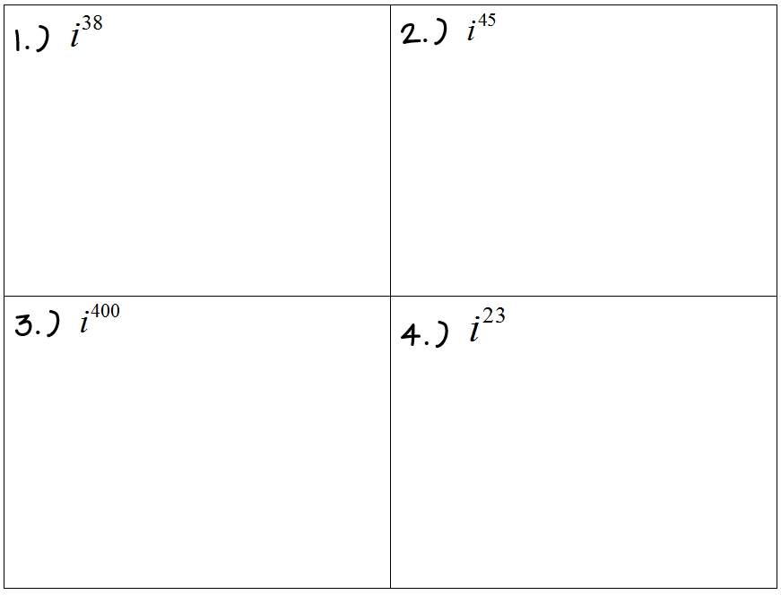

**We can also use ___________ of _____________ with imaginary numbers!**

**Examples: Simplify completely.**

|  |  |  |
| --- | --- | --- |
| 5.) | 6.) | 7.) |

We see the most benefit from imaginary numbers when simplifying radicals. Imaginary numbers allow us to simplify radicals with negatives under an **__________** index!

**Simplifying Radicals with Negatives:**

*Take out the _________ from _______ the radical and write as an “_____” on the outside.

*______________ the radical like normal.

**Examples: Simplify completely.**

|  |  |
| --- | --- |
| 8.) | 9.) |

**What is a complex number?**

A combination of a _________ number and an _____________ number.

**Operations with Imaginary & Complex Numbers:**

When adding, subtracting, and multiplying...treat these exactly how you would if the problem contained an "_______" instead of an "i."

*DO _______ CHANGE THE EXPONENTS!

*Just remember to _________ "i" completely!

|  |  |
| --- | --- |
| **Adding?**  *Combine like-terms. | **Subtracting?**  *Distribute the negative to all of the terms in the (__).  *Combine like-terms. |

**Example: Simplify completely.**

|  |  |
| --- | --- |
| 10.) (6i + 2) + (9 – 3i) | 11.) (5 – 2i) – (–4 – i) |
| 12.) | |

**Multiplying?**

*Distribute & combine like-terms

*Remember your rules of exponents!*

**Example: Simplify completely.**

|  |  |
| --- | --- |
| 13.) 2i(5 + 3i) | 14.) (3 + 2i)(4 - 5i) |
| 15.) (3 - 2i) | |