**Dividing with Imaginary & Complex Numbers**

**Rules:**

*No i's in the _____________________________

*Make sure i's are in _________________ form…meaning nothing is ______________ than “____”

We saw in Keeper # 4, that sometimes the “i” in the denominator eliminates itself simply by subtracting exponents.

**Ex. # 1: Simplify completely.**

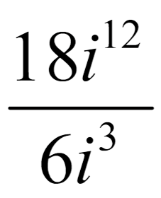

But what happens when there are no other “i’s” in the problem to do that? We must _________________________________________

to eliminate the “i.”

**Steps to Rationalizing the Denominator:**

1.) Simplify the “_______” completely

2.) _________________ the ______________ & _________________ by “i”

3.) ________________ the fraction completely

**Ex. # 2: Simplify completely.**

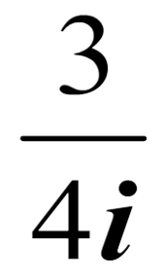

**Ex. # 3: Simplify completely.**



**Special Cases:**

When there is a complex number (real number + imaginary number) in the denominator, we must multiply by the ___________________________________ in order to rationalize the denominator.

**Complex Conjugates**

(What to multiply by in order to get rid of the "i")

**- 2 + 3i ---> ____________**

**1 - i ---> ______________**

**Ex. # 4: Simplify completely.**



**Ex. # 5: Simplify completely.**

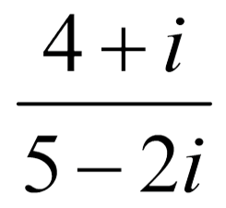

**Graphing Imaginary & Complex Numbers**

Because complex numbers consist of both real and imaginary parts, we must use a special coordinate plane, called the complex plane, to graph them.

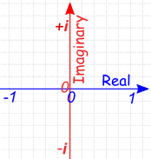

The real numbers run _____ and _____.

The imaginary numbers run ___ and ________.

In the complex plane, the value of a single complex number is represented by the position of the point, so each complex number A + B*i* can be expressed as the ordered pair ________…however, it does not represent a single point like the coordinate plane.

**Ex. # 6: Graph the complex numbers.**

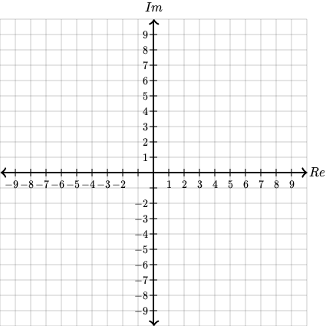

A.) 4 – 3i

B.) 5 + 2i

C.) 6i

D.) – 7 + 5i

The **___________________________ of a**complex number**,** a+bi, is defined as the _____________ between the _____________ and the point ___________ in the complex plane.

**Ex # 7: Find the value.**



**Ex. # 8: Find the distance between point B and point D.**