Honors Algebra 2 Name: _________________________________

Dividing & Graphing Imaginary & Complex Numbers Block: ____________ Date: ________________

**Simplify completely.**

|  |  |
| --- | --- |
| 1.) | 2.) |
| 3.) | 4.) |

**5.) Graph.**

|  |  |  |  |
| --- | --- | --- | --- |
| A. 3i - 2 | B. – 8i | C. 1 - i | D. – 4 + 2i |

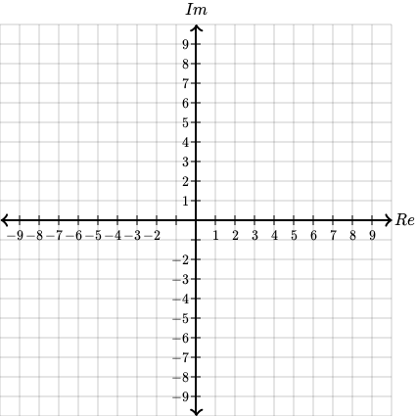

**Find the value.**

|  |  |
| --- | --- |
| 6.) | 7.) |

**Find the distance…**

|  |  |
| --- | --- |
| 8.) between point A and point D | 9.) between point B and point C |