*Can be used to solve __________________ quadratic equation.

**How to Organize Your CTS Work**

**1)** Get equation in form $x^{2}+bx=everything else$

**\*Your leading coefficient MUST by equal to 1. If it is not, divide ALL of the terms by the leading coefficient.**

**2)** In left margin

 **3)** Lay out your work to prepare to “add-in” the “complete the square” term.

 = everything else +



identical



**4)** “Add-in” the “complete the square” term.



 = everything else +

**5)** Rewrite the **Perfect Trinomial** as a **Perfect Square**.



**6)** Take the square root of both sides to **solve**.

**Example: Solve by completing the square.**

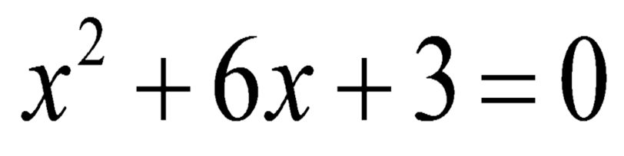

**Example: Solve by completing the square.**

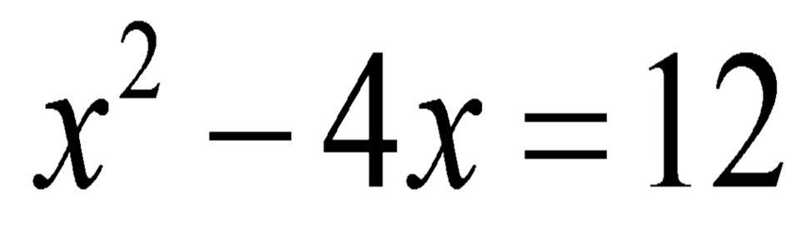

**Example: Solve by completing the square.**

