**Polynomials can be classified in two ways:**

(1) by _________________________

(2) by _________________________ - ____________________ _______________________ on a variable.

**Classifying by number of terms...**

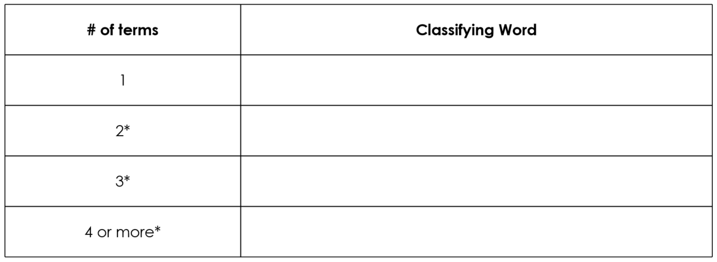

**Classifying by degree...**

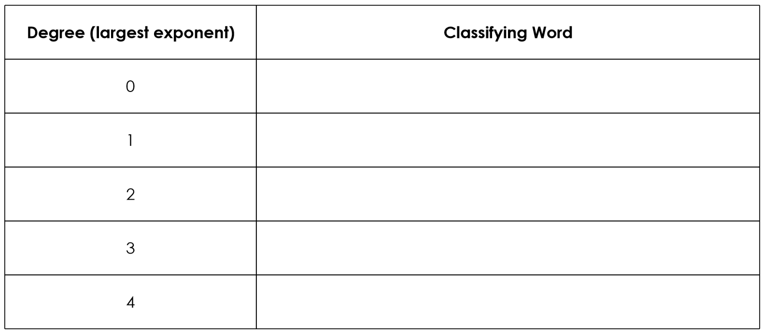

For degrees of 5 or higher, we just say ____ degree or degree of ____.

**Does order matter?**

Yes! We always write polynomials in **______________________________________________.**

**Adding Polynomials**

Adding polynomials is as simple as ___________________

____________________. Remember you do ______________ change the exponents!

**Example # 1: Simplify completely.**

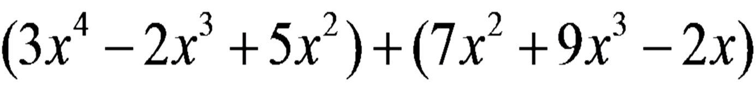

**Subtracting Polynomials**

Distribute the __________ sign, then combine like terms. Remember you do __________ change the exponents!

**Example # 2: Simplify completely.**

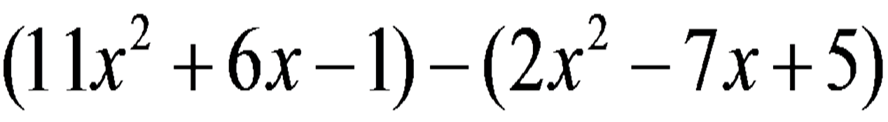

**Multiplying Polynomials**

Multiply the _______________________ and _____________ the exponents when multiplying like __________________. If the variables are different, write them next to one another in _____________________________________ order. If the bases are **____________________**, write them in alphabetical order.

**Example # 3: Simplify completely.**

|  |  |
| --- | --- |
|  |  |
| (c) |  |