**Honors Algebra 2 Name: _______________________**

**Sketching Graphs of Polynomial Functions Date: ______________ Block: ____**

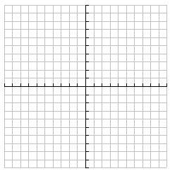**1. **

|  |  |
| --- | --- |
| **Number of Turns:** | **Zeros (w/multiplicity):** |
| **Y-Intercept:** | **End Behavior:** |

**2. **

|  |  |
| --- | --- |
| **Number of Turns:** | **Zeros (w/multiplicity):** |
| **Y-Intercept:** | **End Behavior:** |

**3. **

|  |  |
| --- | --- |
| **Number of Turns:** | **Zeros (w/multiplicity):** |
| **Y-Intercept:** | **End Behavior:** |

**4. **

|  |  |
| --- | --- |
| **Number of Turns:** | **Zeros (w/multiplicity):** |
| **Y-Intercept:** | **End Behavior:** |

**5. **

|  |  |
| --- | --- |
| **Number of Turns:** | **Zeros (w/multiplicity):** |
| **Y-Intercept:** | **End Behavior:** |

**6. **

|  |  |
| --- | --- |
| **Number of Turns:** | **Zeros (w/multiplicity):** |
| **Y-Intercept:** | **End Behavior:** |

**7. **

|  |  |
| --- | --- |
| **Number of Turns:** | **Zeros (w/multiplicity):** |
| **Y-Intercept:** | **End Behavior:** |

**8. **

|  |  |
| --- | --- |
| **Number of Turns:** | **Zeros (w/multiplicity):** |
| **Y-Intercept:** | **End Behavior:** |