Honors Algebra 2 Name: ______________________

Unit 4 Review: Radicals & Rational Exponents Date: _____________ Block: _____

**Perform the indicated operation. Write your answer in simplest radical form.**

|  |  |
| --- | --- |
| 1.) | 2.) |
| 3.) | 4.) |
| Rewrite the expression in radical form.  5.)  6.) | Rewrite the expression with rational exponents.  7.)  8) |

|  |  |
| --- | --- |
| 9) Simplify the expression . |  |
| 10.) Simplify completely. $2\sqrt{x^{4}y^{3}}*5\sqrt{x^{3}yz^{2}}$ | |
| 11.) State the radical conjugate for the expression  and then simplify. | |

**Simplify each expression completely. Write your answer in simplest radical form.**

|  |  |  |  |
| --- | --- | --- | --- |
| 12) | 13) | | 14) |
| 15) | 16) | | 17) |
| 18.) | | 19.) | |
| 20.) | | 21.) | |

22) Rewrite using rational exponents. Write your answer in simplest form.

23.) A stone is dropped from a height of 350 feet. The time it takes for the stone to fall to a height of *h* feet is given by the function  where *t* is the time in seconds. What is the height of the stone after 4 seconds?

**Describe the characteristics for each function.**

24. 

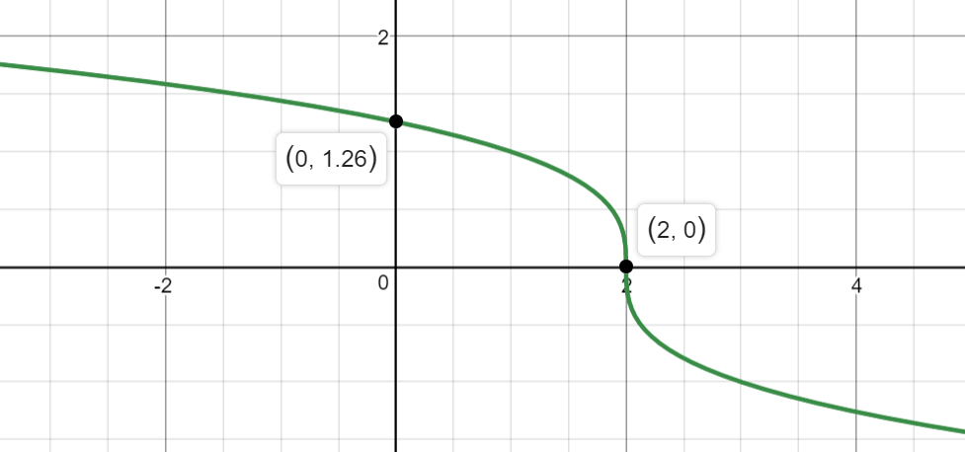

|  |  |  |
| --- | --- | --- |
| Characteristics: | | |
| Domain: | Range: | x-intercept: _______  y-intercept: _______ |
| Interval of Increase:  Interval of Decrease: | Absolute Maximum:  Absolute Minimum: | End Behavior: |

25. 

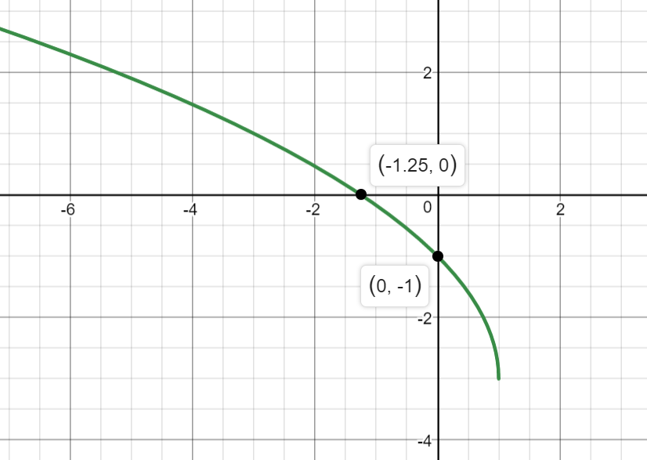

|  |  |  |
| --- | --- | --- |
| Characteristics: | | |
| Domain: | Range: | x-intercept: _______  y-intercept: _______ |
| Interval of Increase:  Interval of Decrease: | Absolute Maximum:  Absolute Minimum: | End Behavior: |

**Describe the transformations for the function.**

26.

|  |  |  |  |  |  |  |  |  |
| --- | --- | --- | --- | --- | --- | --- | --- | --- |
| **Parent Function:** | **Vertical Reflection:** | **Horizontal Reflection:** | **Vertical Stretch by?** | **Vertical Shrink by?** | **Horizontal Stretch by?** | **Horizontal Shrink by?** | **Horizontal Shift: Direction? How many?** | **Vertical Shift: Direction? How many?** |
|  |  |  |  |  |  |  |  |  |

27. 

|  |  |  |  |  |  |  |  |  |
| --- | --- | --- | --- | --- | --- | --- | --- | --- |
| **Parent Function:** | **Vertical Reflection:** | **Horizontal Reflection:** | **Vertical Stretch by?** | **Vertical Shrink by?** | **Horizontal Stretch by?** | **Horizontal Shrink by?** | **Horizontal Shift: Direction? How many?** | **Vertical Shift: Direction? How many?** |
|  |  |  |  |  |  |  |  |  |

28. 

|  |  |  |  |  |  |  |  |  |
| --- | --- | --- | --- | --- | --- | --- | --- | --- |
| **Parent Function:** | **Vertical Reflection:** | **Horizontal Reflection:** | **Vertical Stretch by?** | **Vertical Shrink by?** | **Horizontal Stretch by?** | **Horizontal Shrink by?** | **Horizontal Shift: Direction? How many?** | **Vertical Shift: Direction? How many?** |
|  |  |  |  |  |  |  |  |  |

29. 

|  |  |  |  |  |  |  |  |  |
| --- | --- | --- | --- | --- | --- | --- | --- | --- |
| **Parent Function:** | **Vertical Reflection:** | **Horizontal Reflection:** | **Vertical Stretch by?** | **Vertical Shrink by?** | **Horizontal Stretch by?** | **Horizontal Shrink by?** | **Horizontal Shift: Direction? How many?** | **Vertical Shift: Direction? How many?** |
|  |  |  |  |  |  |  |  |  |

30. 

|  |  |  |  |  |  |  |  |  |
| --- | --- | --- | --- | --- | --- | --- | --- | --- |
| **Parent Function:** | **Vertical Reflection:** | **Horizontal Reflection:** | **Vertical Stretch by?** | **Vertical Shrink by?** | **Horizontal Stretch by?** | **Horizontal Shrink by?** | **Horizontal Shift: Direction? How many?** | **Vertical Shift: Direction? How many?** |
|  |  |  |  |  |  |  |  |  |

**Graph using transformations. Make sure to include the parent function on your graph.**

31. 

|  |  |  |  |  |  |  |  |  |
| --- | --- | --- | --- | --- | --- | --- | --- | --- |
| **Parent Function:** | **Vertical Reflection:** | **Horizontal Reflection:** | **Vertical Stretch by?** | **Vertical Shrink by?** | **Horizontal Stretch by?** | **Horizontal Shrink by?** | **Horizontal Shift: Direction? How many?** | **Vertical Shift: Direction? How many?** |
|  |  |  |  |  |  |  |  |  |

32. 

|  |  |  |  |  |  |  |  |  |
| --- | --- | --- | --- | --- | --- | --- | --- | --- |
| **Parent Function:** | **Vertical Reflection:** | **Horizontal Reflection:** | **Vertical Stretch by?** | **Vertical Shrink by?** | **Horizontal Stretch by?** | **Horizontal Shrink by?** | **Horizontal Shift: Direction? How many?** | **Vertical Shift: Direction? How many?** |
|  |  |  |  |  |  |  |  |  |

Graph # 31 Below: Graph # 32 Below:

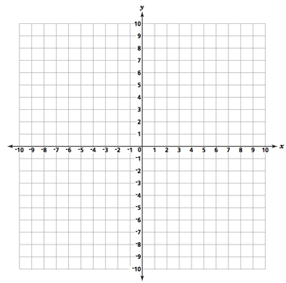

**Solve each equation; round any decimal to the TENTHS place. Remember to check for extraneous solutions when applicable!**

|  |  |
| --- | --- |
| 33. | 34. |

|  |  |
| --- | --- |
| 35. | 36. |
| 37. | 38. |
| 39. | 40. |